Date: 02/04/26
📊 Final Count:
🟢 Bullish | 14
🔴 Bearish | 132
Total | 146

🟢 BULLISH TRADES --- 14
1 | COFORGE
2 | DIXON
3 | KPITTECH
4 | PAGEIND
5 | VBL
6 | ONGC
7 | DMART
8 | BOSCHLTD
9 | PERSISTENT
10 | NATIONALUM
11 | BSE
12 | BDL
13 | BEL
14 | HFCL
🔴 BEARISH TRADES --- 132
1 | ALKEM
2 | BANKBARODA
3 | BLUESTARCO
4 | BRITANNIA
5 | CANBK
6 | COLPAL
7 | CYIENT
8 | DALBHARAT
9 | DIVISLAB
10 | GODREJCP
11 | JUBLFOOD
12 | LODHA
13 | LUPIN
14 | MANKIND
15 | MFSL
16 | NESTLEIND
17 | OIL
18 | PGEL
19 | PATANJALI
20 | POWERGRID
21 | RELIANCE
22 | SBILIFE
23 | SHREECEM
24 | SIEMENS
25 | SYNGENE
26 | TATACONSUM
27 | TATAELXSI
28 | INDHOTEL
29 | TORNTPOWER
30 | UNOMINDA
31 | UPL
32 | UNITDSPR
33 | VOLTAS
34 | INFY
35 | ABCAPITAL
36 | GODREJPROP
37 | IIFL
38 | IRCTC
39 | IREDA
40 | NAUKRI
41 | INOXWIND
42 | INDIGO
43 | RVNL
44 | SUZLON
45 | ADANIENT
46 | BHEL
47 | BIOCON
48 | CGPOWER
49 | CROMPTON
50 | GLENMARK
51 | GRASIM
52 | HUDCO
53 | IEX
54 | IRFC
55 | LICI
56 | NBCC
57 | PPLPHARMA
58 | PFC
59 | SUNPHARMA
60 | TATATECH
61 | PHOENIXLTD
62 | ULTRACEMCO
63 | APOLLOHOSP
64 | FORTIS
65 | POWERINDIA
66 | NUVAMA
67 | TORNTPHARM
68 | AMBER
69 | BHARTIARTL
70 | CIPLA
71 | MCX
72 | POLICYBZR
73 | BHARATFORG
74 | DLF
75 | DRREDDY
76 | KEI
77 | KAYNES
78 | NHPC
79 | PAYTM
80 | 360ONE
81 | SRF
82 | ASIANPAINT
83 | INDUSTOWER
84 | PIDILITIND
85 | IDEA
86 | MUTHOOTFIN
87 | APLAPOLLO
88 | AUBANK
89 | ADANIENSOL
90 | ASHOKLEY
91 | ASTRAL
92 | BAJAJ-AUTO
93 | BAJAJFINSV
94 | BANDHANBNK
95 | BANKINDIA
96 | BPCL
97 | CONCOR
98 | DABUR
99 | EICHERMOT
100 | GMRAIRPORT
101 | HDFCBANK
102 | HEROMOTOCO
103 | HINDPETRO
104 | HINDZINC
105 | ICICIPRULI
106 | IDFCFIRSTB
107 | INDIANB
108 | IOC
109 | IGL
110 | INDUSINDBK
111 | JIOFIN
112 | KFINTECH
113 | KOTAKBANK
114 | LTF
115 | M&M
116 | MAXHEALTH
117 | NTPC
118 | PIIND
119 | POLYCAB
120 | PRESTIGE
121 | PNB
122 | SHRIRAMFIN
123 | SBIN
124 | TVSMOTOR
125 | TMPV
126 | TATAPOWER
127 | FEDERALBNK
128 | TIINDIA
129 | UNIONBANK
130 | YESBANK
131 | MOTHERSON
132 | HDFCLIFE

Trade Taken
🔴 BEARISH SIGNAL --- LODHA

Nifty Bias : ⚠️ CHOPPY — Choppy ⚠️
Crossover : 2026-03-19 09:30 (14 days ago)
Pullback : 2026-04-01 15:00
High ₹686.9 ≥ EMA9(High) ₹685.32
Low ₹682.4 (breakdown level)
Confirm : 2026-04-02 09:15 (+2 candle)
Close ₹661.25 < Pullback Low ₹682.4 (body breakdown)
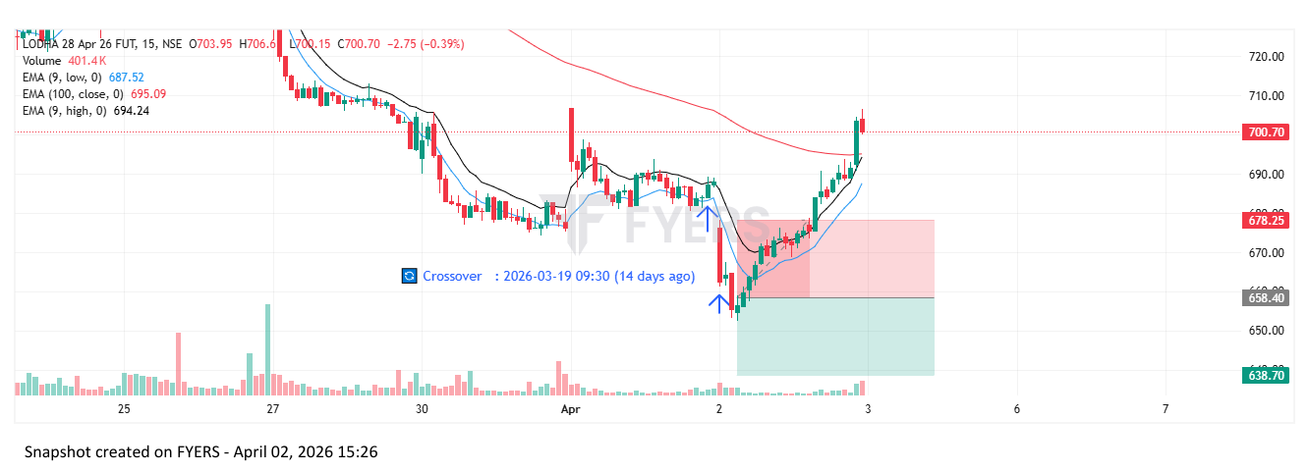
🔴 BEARISH SIGNAL --- PGEL

Nifty Bias : ⚠️ CHOPPY — Choppy ⚠️
Crossover : 2026-03-27 11:00 (6 days ago)
Pullback : 2026-04-01 15:15
High ₹485 ≥ EMA9(High) ₹483.81
Low ₹479.4 (breakdown level)
Confirm : 2026-04-02 09:15 (+1 candle)
Close ₹460.5 < Pullback Low ₹479.4 (body breakdown)
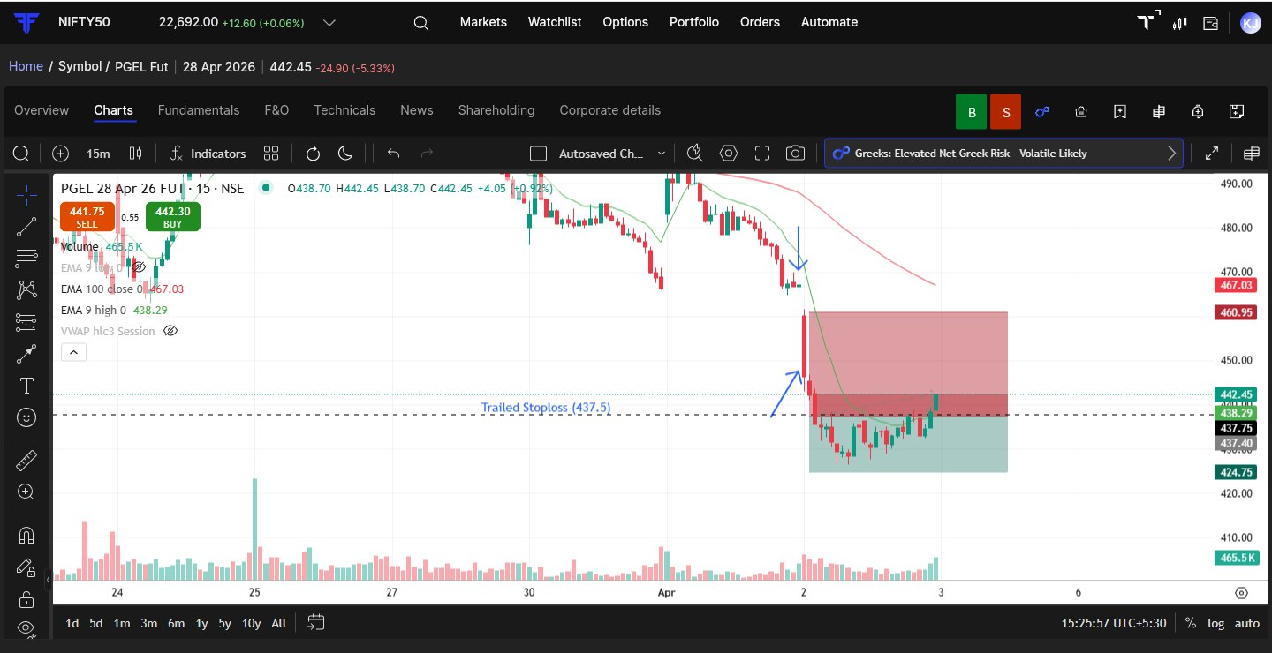
🔴 BEARISH SIGNAL --- SBILIFE

Nifty Bias : ⚠️ CHOPPY — Choppy ⚠️
Crossover : 2026-03-19 12:00 (14 days ago)
Pullback : 2026-04-01 14:45
High ₹1788.9 ≥ EMA9(High) ₹1783.3
Low ₹1778.7 (breakdown level)
Confirm : 2026-04-02 09:15 (+3 candle)
Close ₹1753.8 < Pullback Low ₹1778.7 (body breakdown)
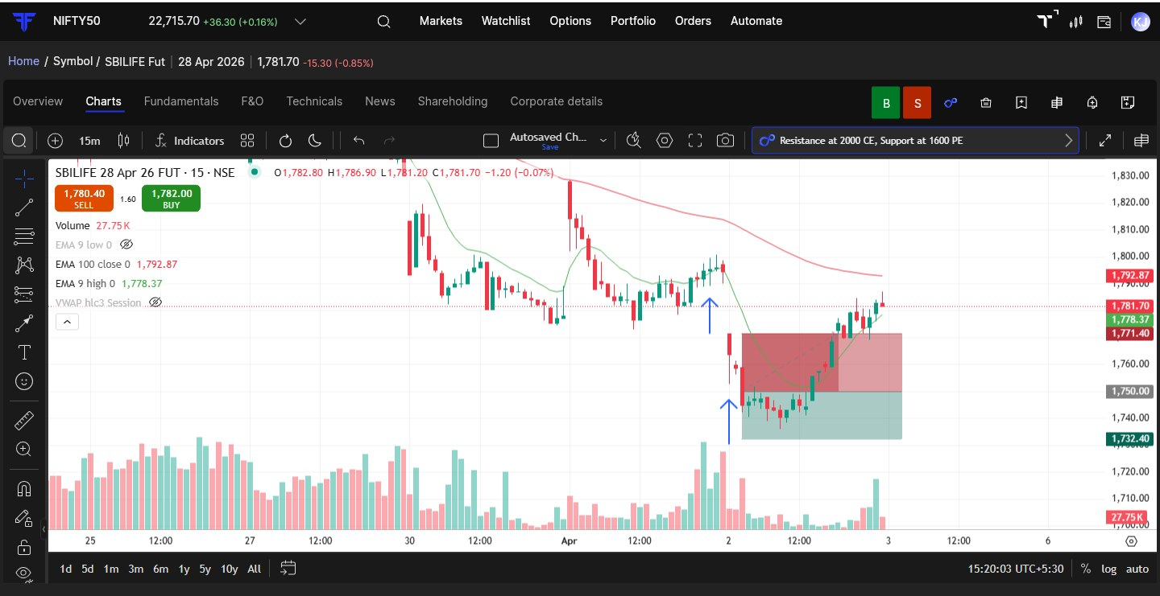
🟢 BULLISH SIGNAL --- PAGEIND

Nifty Bias : 🔴 SHORT — Counter Trend ⚠️
Crossover : 2026-04-01 10:15 (a day ago)
Pullback : 2026-04-02 09:15
Low ₹32225 ≤ EMA9(Low) ₹32464.49
High ₹32940 (breakout level)
Confirm : 2026-04-02 09:30 (+1 candle)
Close ₹33330 > Pullback High ₹32940 (body breakout)
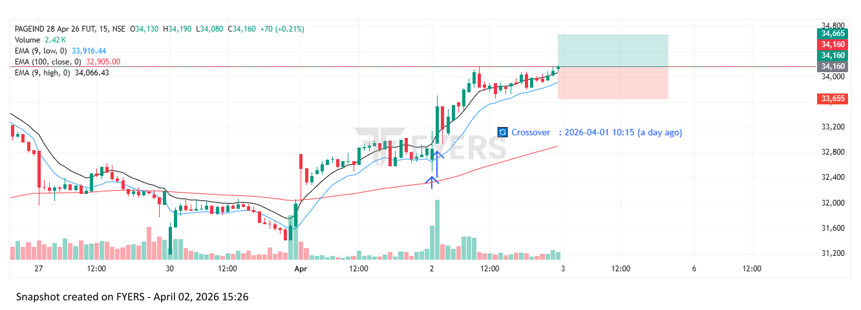

Trade Not Taken
🔴 BEARISH SIGNAL --- ALKEM

Nifty Bias : ⚠️ CHOPPY — Choppy ⚠️
Crossover : 2026-04-01 11:30 (a day ago)
Pullback : 2026-04-01 15:00
High ₹5260.5 ≥ EMA9(High) ₹5258.19
Low ₹5225.5 (breakdown level)
Confirm : 2026-04-02 09:15 (+2 candle)
Close ₹5119 < Pullback Low ₹5225.5 (body breakdown)

🔴 BEARISH SIGNAL --- BANKBARODA

Nifty Bias : ⚠️ CHOPPY — Choppy ⚠️
Crossover : 2026-03-27 09:15 (6 days ago)
Pullback : 2026-04-01 15:15
High ₹253.85 ≥ EMA9(High) ₹253.42
Low ₹251.78 (breakdown level)
Confirm : 2026-04-02 09:15 (+1 candle)
Close ₹245.66 < Pullback Low ₹251.78 (body breakdown)
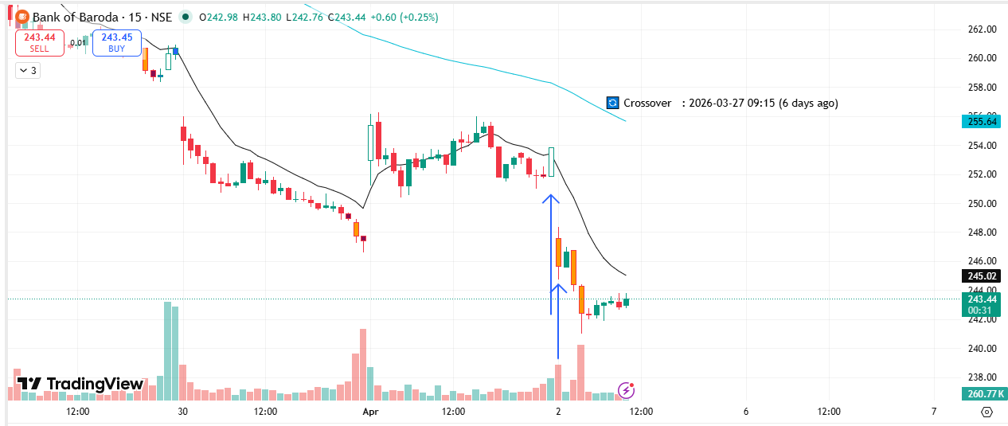
🔴 BEARISH SIGNAL --- BLUESTARCO

Nifty Bias : ⚠️ CHOPPY — Choppy ⚠️
Crossover : 2026-03-27 11:45 (6 days ago)
Pullback : 2026-04-01 15:00
High ₹1564.8 ≥ EMA9(High) ₹1556.37
Low ₹1546.7 (breakdown level)
Confirm : 2026-04-02 09:15 (+2 candle)
Close ₹1474 < Pullback Low ₹1546.7 (body breakdown)
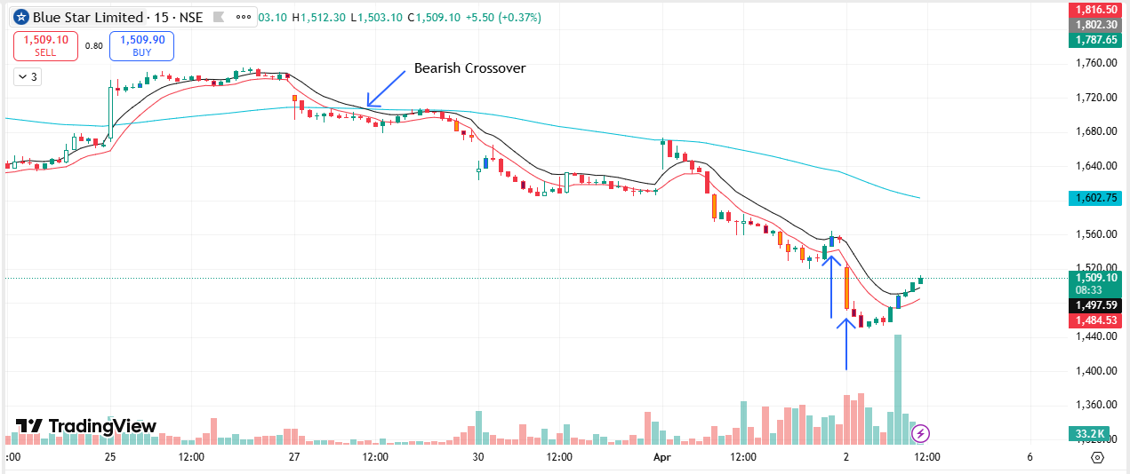
🔴 BEARISH SIGNAL --- BRITANNIA

Nifty Bias : ⚠️ CHOPPY — Choppy ⚠️
Crossover : 2026-03-27 11:15 (6 days ago)
Pullback : 2026-04-01 15:00
High ₹5481 ≥ EMA9(High) ₹5471.87
Low ₹5451 (breakdown level)
Confirm : 2026-04-02 09:15 (+2 candle)
Close ₹5412 < Pullback Low ₹5451 (body breakdown)
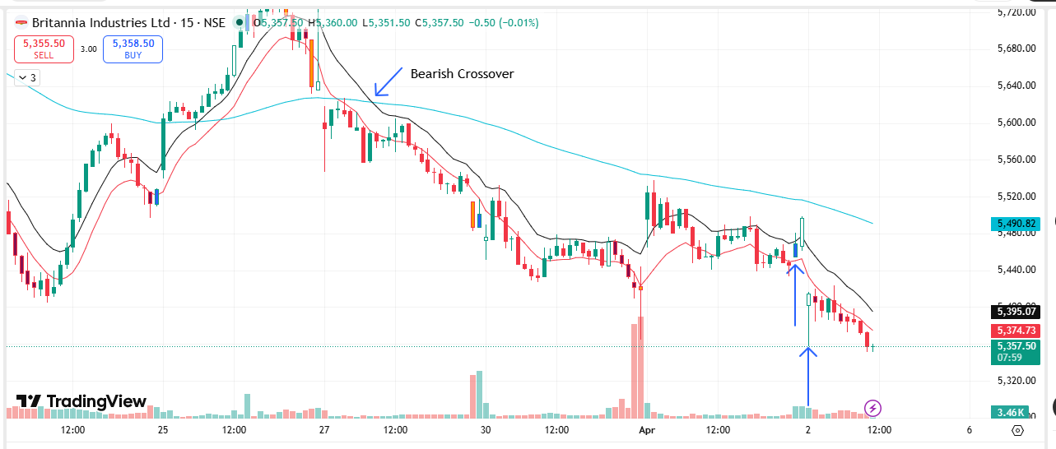
🔴 BEARISH SIGNAL --- CANBK

Nifty Bias : ⚠️ CHOPPY — Choppy ⚠️
Crossover : 2026-03-27 10:00 (6 days ago)
Pullback : 2026-04-01 15:15
High ₹128 ≥ EMA9(High) ₹127.92
Low ₹127 (breakdown level)
Confirm : 2026-04-02 09:15 (+1 candle)
Close ₹123.02 < Pullback Low ₹127 (body breakdown)
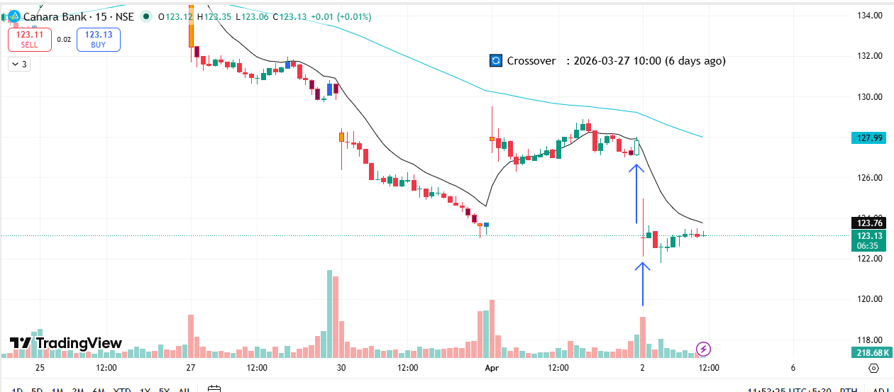
🟢 BULLISH SIGNAL --- COFORGE

Nifty Bias : ⚠️ CHOPPY — Choppy ⚠️
Crossover : 2026-04-01 09:45 (a day ago)
Pullback : 2026-04-01 15:00
Low ₹1147.9 ≤ EMA9(Low) ₹1152.81
High ₹1157.5 (breakout level)
Confirm : 2026-04-02 09:15 (+2 candle)
Close ₹1159.1 > Pullback High ₹1157.5 (body breakout)
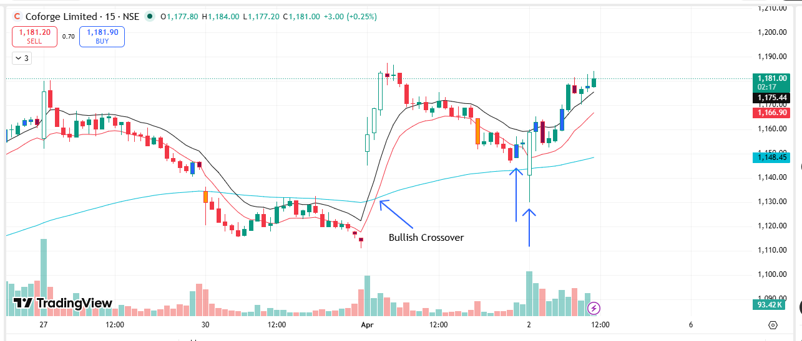
🔴 BEARISH SIGNAL --- COLPAL

Nifty Bias : ⚠️ CHOPPY — Choppy ⚠️
Crossover : 2026-03-27 14:00 (6 days ago)
Pullback : 2026-04-01 15:15
High ₹1832 ≥ EMA9(High) ₹1828.51
Low ₹1817.5 (breakdown level)
Confirm : 2026-04-02 09:15 (+1 candle)
Close ₹1788.4 < Pullback Low ₹1817.5 (body breakdown)
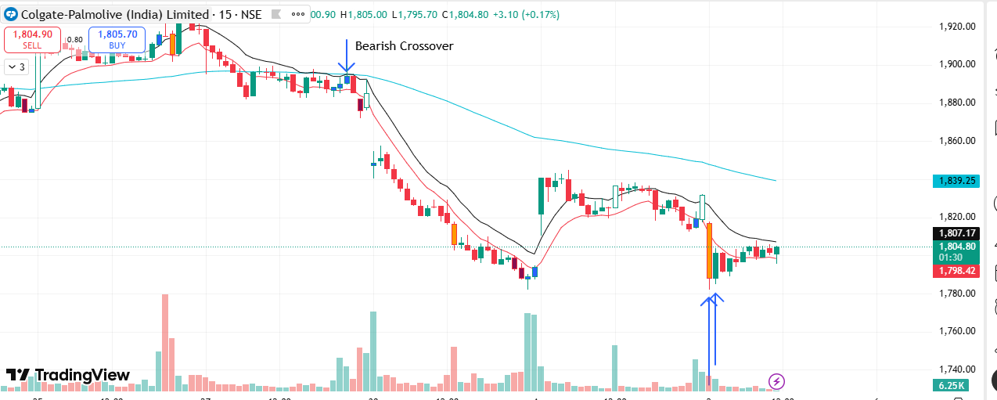
🔴 BEARISH SIGNAL --- CYIENT

Nifty Bias : ⚠️ CHOPPY — Choppy ⚠️
Crossover : 2026-04-01 13:30 (20 hours ago)
Pullback : 2026-04-01 15:15
High ₹786.5 ≥ EMA9(High) ₹783.36
Low ₹777.65 (breakdown level)
Confirm : 2026-04-02 09:15 (+1 candle)
Close ₹775.25 < Pullback Low ₹777.65 (body breakdown)

🔴 BEARISH SIGNAL --- DALBHARAT

Nifty Bias : ⚠️ CHOPPY — Choppy ⚠️
Crossover : 2026-04-01 13:45 (20 hours ago)
Pullback : 2026-04-01 15:00
High ₹1809.9 ≥ EMA9(High) ₹1808.73
Low ₹1799.7 (breakdown level)
Confirm : 2026-04-02 09:15 (+2 candle)
Close ₹1767.1 < Pullback Low ₹1799.7 (body breakdown)
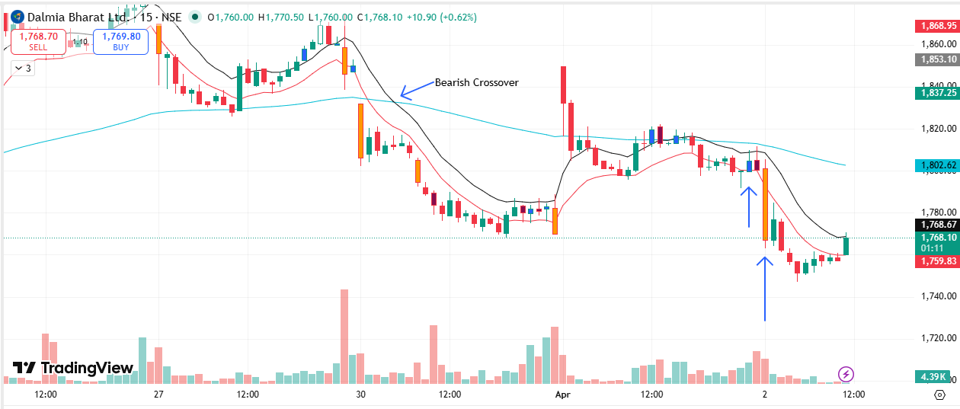
🔴 BEARISH SIGNAL --- DIVISLAB

Nifty Bias : ⚠️ CHOPPY — Choppy ⚠️
Crossover : 2026-04-01 13:15 (20 hours ago)
Pullback : 2026-04-01 15:00
High ₹5937 ≥ EMA9(High) ₹5928.26
Low ₹5900 (breakdown level)
Confirm : 2026-04-02 09:15 (+2 candle)
Close ₹5706 < Pullback Low ₹5900 (body breakdown)
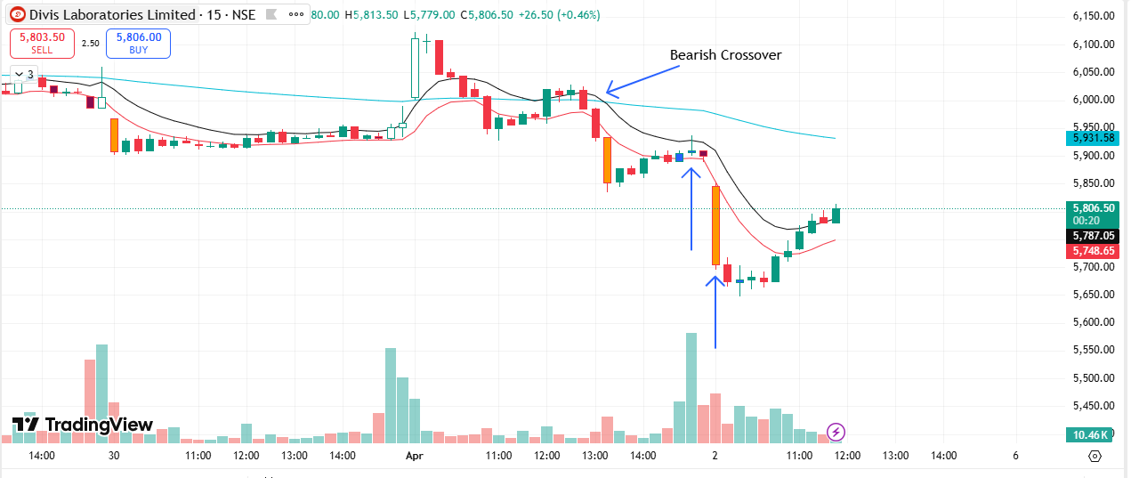
🔴 BEARISH SIGNAL --- GODREJCP

Nifty Bias : ⚠️ CHOPPY — Choppy ⚠️
Crossover : 2026-03-27 11:45 (6 days ago)
Pullback : 2026-04-01 15:15
High ₹1002 ≥ EMA9(High) ₹999.77
Low ₹994.75 (breakdown level)
Confirm : 2026-04-02 09:15 (+1 candle)
Close ₹974.4 < Pullback Low ₹994.75 (body breakdown)
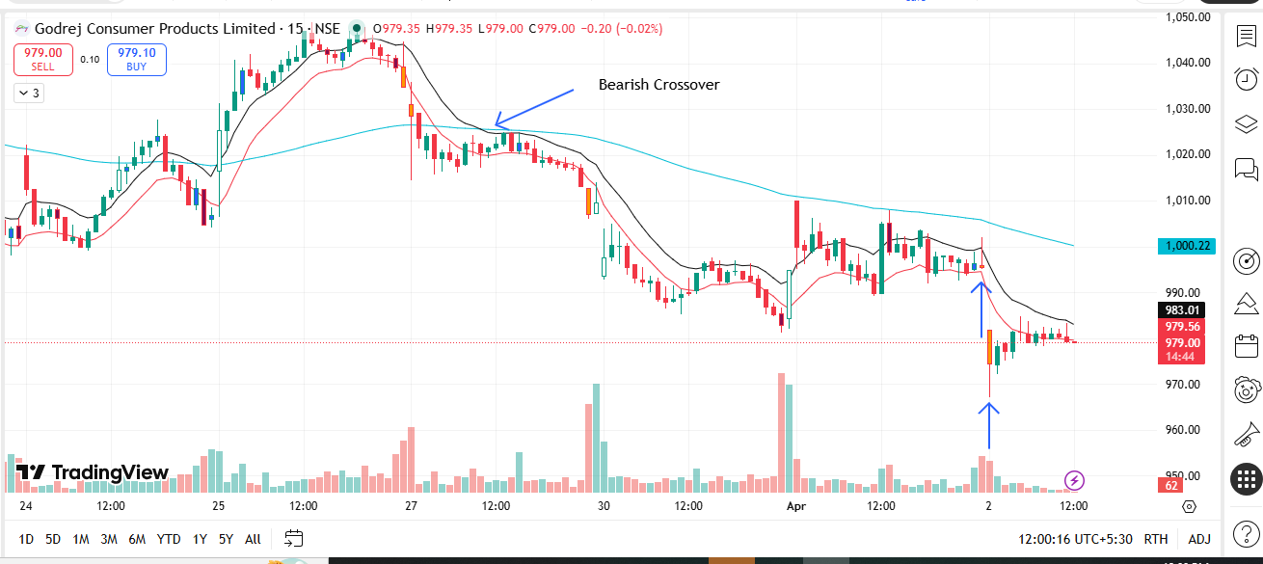
🔴 BEARISH SIGNAL --- JUBLFOOD

Nifty Bias : ⚠️ CHOPPY — Choppy ⚠️
Crossover : 2026-03-27 14:00 (6 days ago)
Pullback : 2026-04-01 15:00
High ₹443.8 ≥ EMA9(High) ₹443.63
Low ₹441.65 (breakdown level)
Confirm : 2026-04-02 09:15 (+2 candle)
Close ₹436.25 < Pullback Low ₹441.65 (body breakdown)
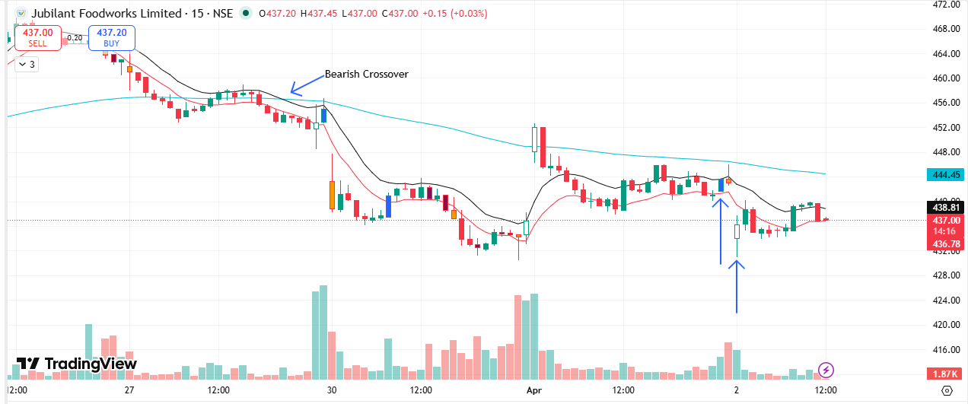
🔴 BEARISH SIGNAL --- LUPIN

Nifty Bias : ⚠️ CHOPPY — Choppy ⚠️
Crossover : 2026-04-01 11:00 (a day ago)
Pullback : 2026-04-01 15:00
High ₹2279.9 ≥ EMA9(High) ₹2279.55
Low ₹2266.8 (breakdown level)
Confirm : 2026-04-02 09:15 (+2 candle)
Close ₹2188.7 < Pullback Low ₹2266.8 (body breakdown)
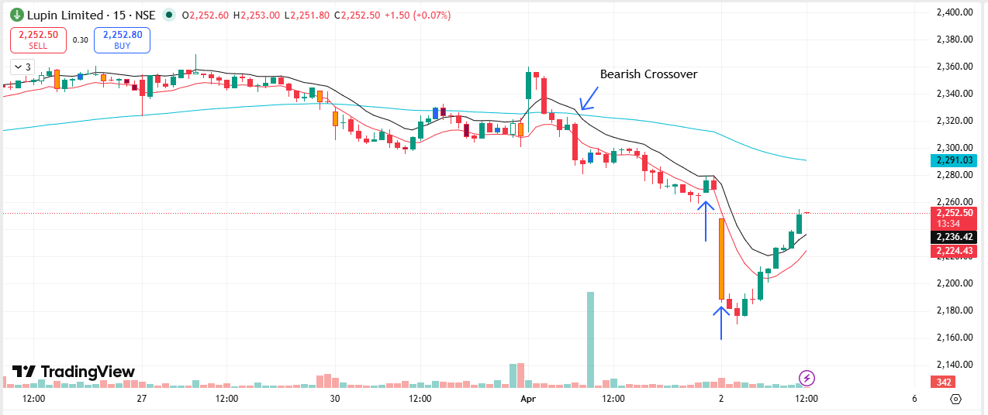
🔴 BEARISH SIGNAL --- MANKIND

Nifty Bias : ⚠️ CHOPPY — Choppy ⚠️
Crossover : 2026-04-01 11:00 (a day ago)
Pullback : 2026-04-01 15:00
High ₹2005 ≥ EMA9(High) ₹1998.27
Low ₹1992.4 (breakdown level)
Confirm : 2026-04-02 09:15 (+2 candle)
Close ₹1935.2 < Pullback Low ₹1992.4 (body breakdown)
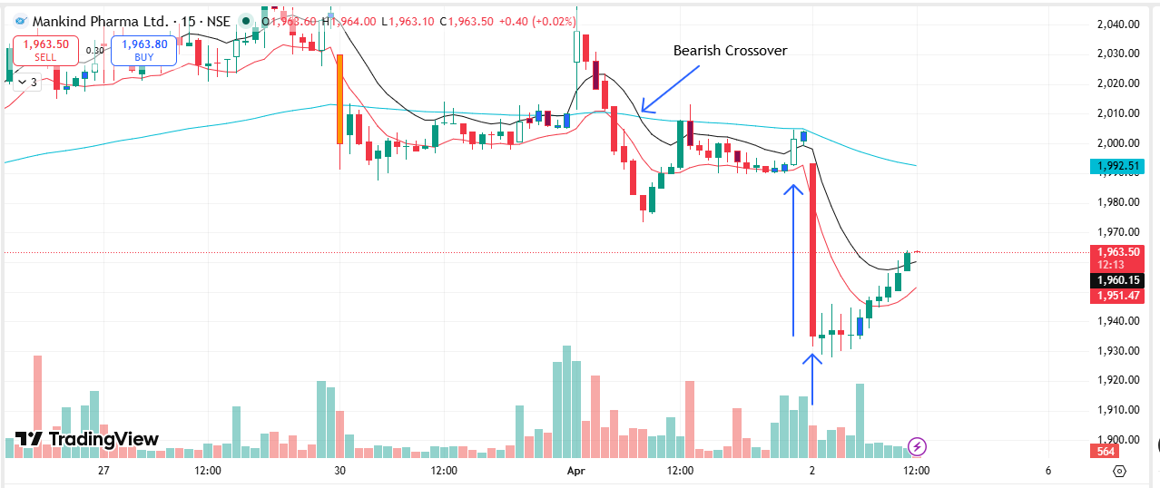
🔴 BEARISH SIGNAL --- MFSL

Nifty Bias : ⚠️ CHOPPY — Choppy ⚠️
Crossover : 2026-03-25 15:00 (8 days ago)
Pullback : 2026-04-01 15:15
High ₹1488.1 ≥ EMA9(High) ₹1485.54
Low ₹1473.3 (breakdown level)
Confirm : 2026-04-02 09:15 (+1 candle)
Close ₹1441.3 < Pullback Low ₹1473.3 (body breakdown)
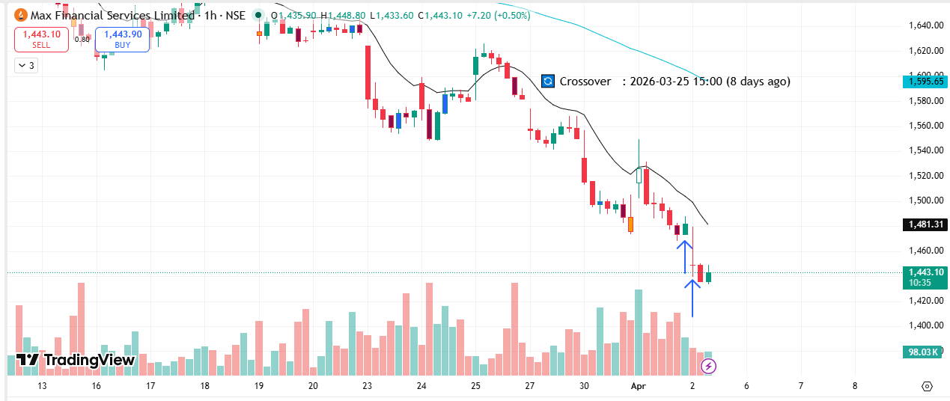
🔴 BEARISH SIGNAL --- NESTLEIND

Nifty Bias : ⚠️ CHOPPY — Choppy ⚠️
Crossover : 2026-03-30 10:00 (3 days ago)
Pullback : 2026-04-01 15:00
High ₹1182.6 ≥ EMA9(High) ₹1176.59
Low ₹1172.8 (breakdown level)
Confirm : 2026-04-02 09:15 (+2 candle)
Close ₹1164.8 < Pullback Low ₹1172.8 (body breakdown)
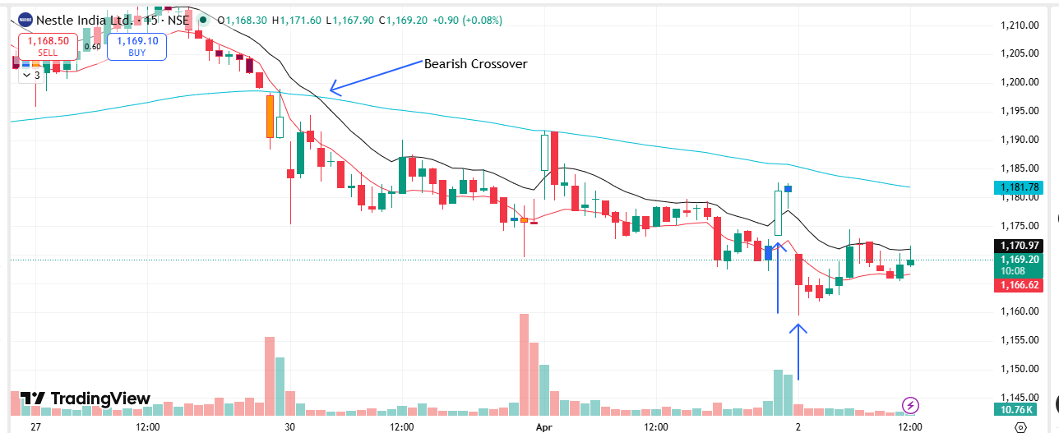
🔴 BEARISH SIGNAL --- OIL

Nifty Bias : ⚠️ CHOPPY — Choppy ⚠️
Crossover : 2026-04-01 13:15 (20 hours ago)
Pullback : 2026-04-01 15:00
High ₹475.25 ≥ EMA9(High) ₹475.18
Low ₹472 (breakdown level)
Confirm : 2026-04-02 09:15 (+2 candle)
Close ₹464.05 < Pullback Low ₹472 (body breakdown)
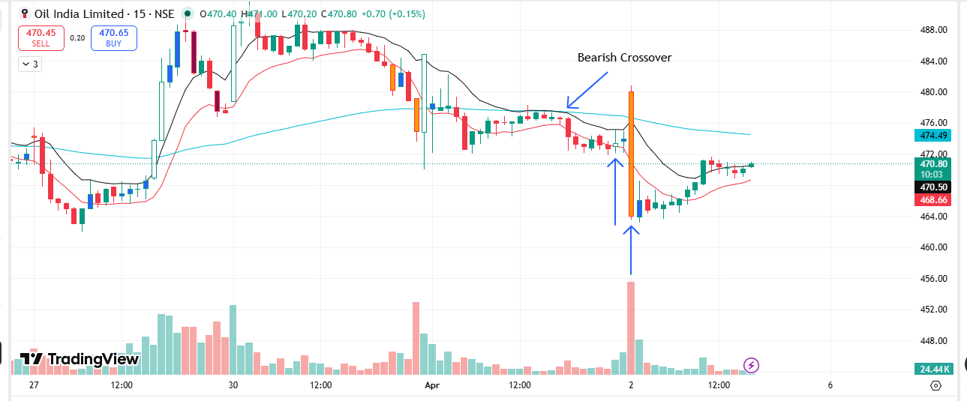
🔴 BEARISH SIGNAL --- PATANJALI

Nifty Bias : ⚠️ CHOPPY — Choppy ⚠️
Crossover : 2026-03-30 09:15 (3 days ago)
Pullback : 2026-04-01 14:45
High ₹470.45 ≥ EMA9(High) ₹470.45
Low ₹467 (breakdown level)
Confirm : 2026-04-02 09:15 (+3 candle)
Close ₹460.05 < Pullback Low ₹467 (body breakdown)
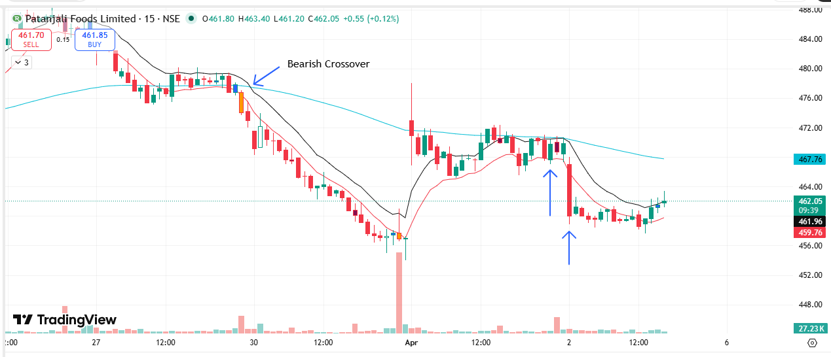
🔴 BEARISH SIGNAL --- POWERGRID

Nifty Bias : ⚠️ CHOPPY — Choppy ⚠️
Crossover : 2026-04-01 11:45 (a day ago)
Pullback : 2026-04-01 15:00
High ₹293.2 ≥ EMA9(High) ₹292.89
Low ₹290.85 (breakdown level)
Confirm : 2026-04-02 09:15 (+2 candle)
Close ₹285.65 < Pullback Low ₹290.85 (body breakdown)
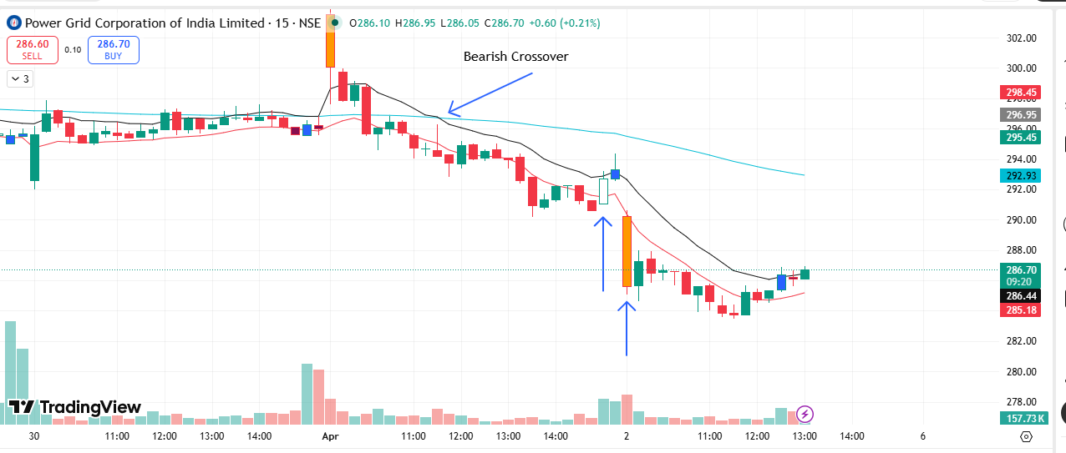
🔴 BEARISH SIGNAL --- RELIANCE

Nifty Bias : ⚠️ CHOPPY — Choppy ⚠️
Crossover : 2026-04-01 13:45 (20 hours ago)
Pullback : 2026-04-01 15:00
High ₹1371.3 ≥ EMA9(High) ₹1371.21
Low ₹1364.6 (breakdown level)
Confirm : 2026-04-02 09:15 (+2 candle)
Close ₹1350.8 < Pullback Low ₹1364.6 (body breakdown)
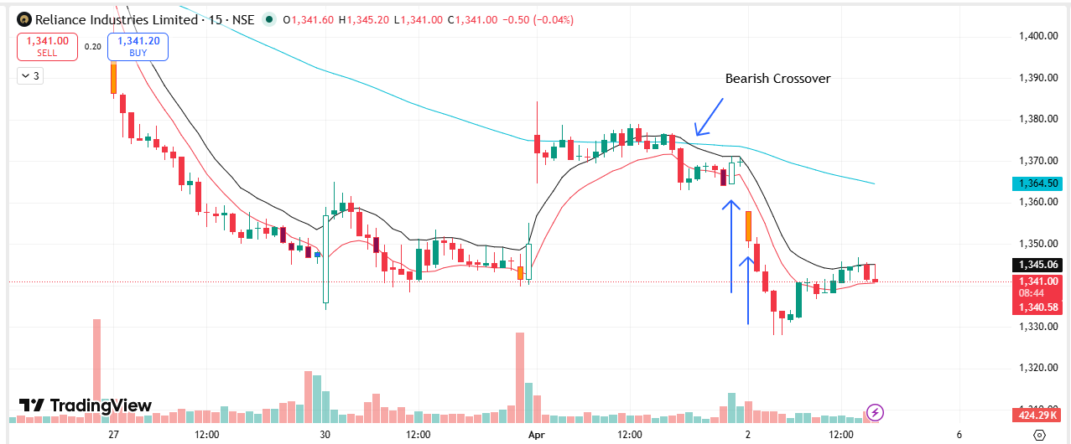
🔴 BEARISH SIGNAL --- SHREECEM

Nifty Bias : ⚠️ CHOPPY — Choppy ⚠️
Crossover : 2026-03-30 10:45 (3 days ago)
Pullback : 2026-04-01 14:45
High ₹23255 ≥ EMA9(High) ₹23248.23
Low ₹23200 (breakdown level)
Confirm : 2026-04-02 09:15 (+3 candle)
Close ₹22850 < Pullback Low ₹23200 (body breakdown)
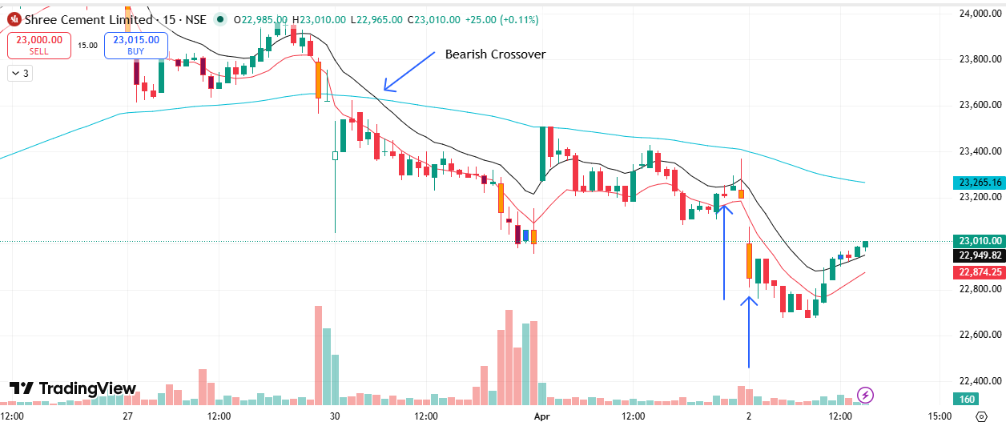
🔴 BEARISH SIGNAL --- SIEMENS

Nifty Bias : ⚠️ CHOPPY — Choppy ⚠️
Crossover : 2026-04-01 14:45 (19 hours ago)
Pullback : 2026-04-01 15:15
High ₹3024 ≥ EMA9(High) ₹3024
Low ₹3012.4 (breakdown level)
Confirm : 2026-04-02 09:15 (+1 candle)
Close ₹2920.7 < Pullback Low ₹3012.4 (body breakdown)
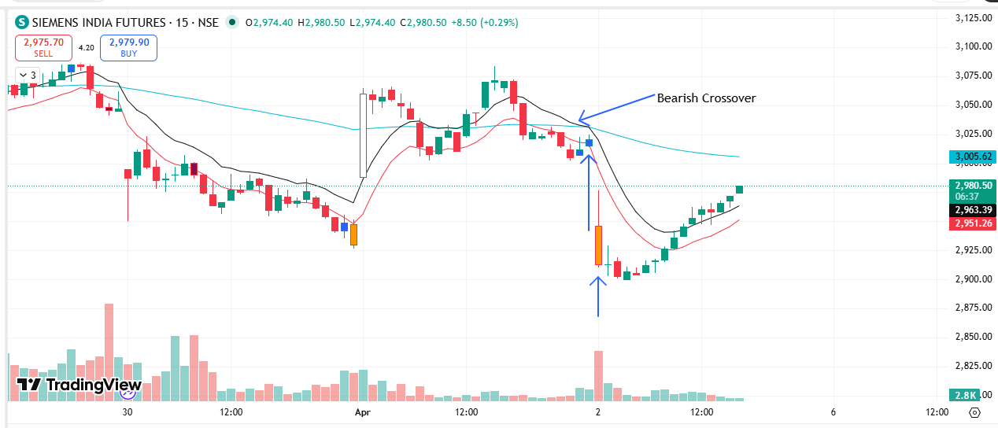
🔴 BEARISH SIGNAL --- SYNGENE

Nifty Bias : ⚠️ CHOPPY — Choppy ⚠️
Crossover : 2026-03-30 09:45 (3 days ago)
Pullback : 2026-04-01 15:00
High ₹396.65 ≥ EMA9(High) ₹395.93
Low ₹394 (breakdown level)
Confirm : 2026-04-02 09:15 (+2 candle)
Close ₹387 < Pullback Low ₹394 (body breakdown)

🔴 BEARISH SIGNAL --- TATACONSUM

Nifty Bias : ⚠️ CHOPPY — Choppy ⚠️
Crossover : 2026-03-30 09:15 (3 days ago)
Pullback : 2026-04-01 15:15
High ₹1026.7 ≥ EMA9(High) ₹1023.28
Low ₹1021.6 (breakdown level)
Confirm : 2026-04-02 09:15 (+1 candle)
Close ₹1019.8 < Pullback Low ₹1021.6 (body breakdown)
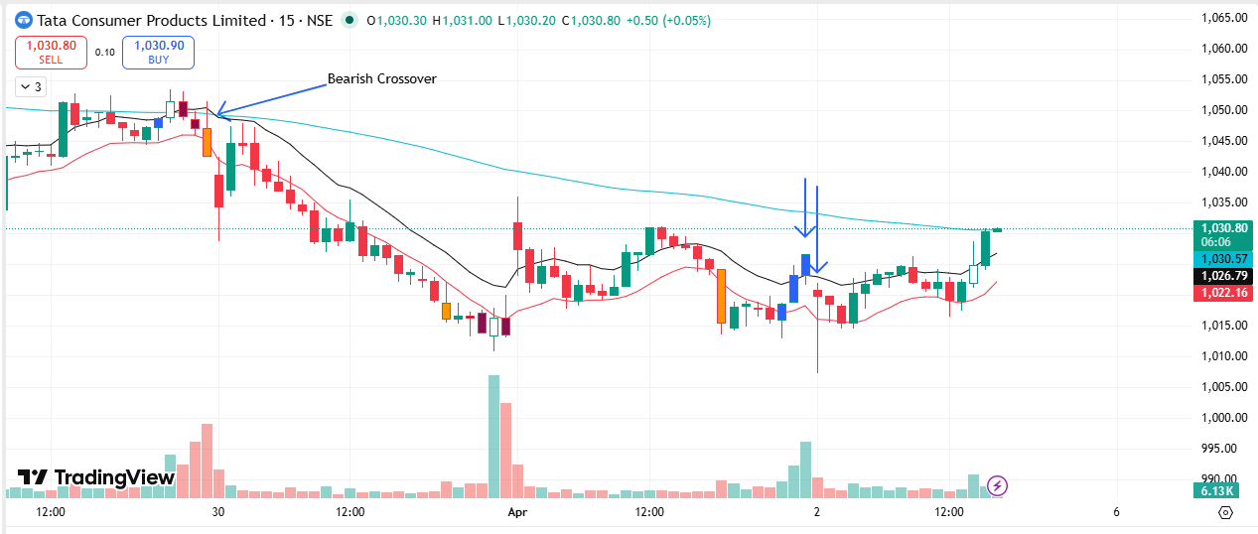
🔴 BEARISH SIGNAL --- TATAELXSI

Nifty Bias : ⚠️ CHOPPY — Choppy ⚠️
Crossover : 2026-04-01 14:45 (19 hours ago)
Pullback : 2026-04-01 15:00
High ₹4140 ≥ EMA9(High) ₹4138.63
Low ₹4107 (breakdown level)
Confirm : 2026-04-02 09:15 (+2 candle)
Close ₹4064.1 < Pullback Low ₹4107 (body breakdown)
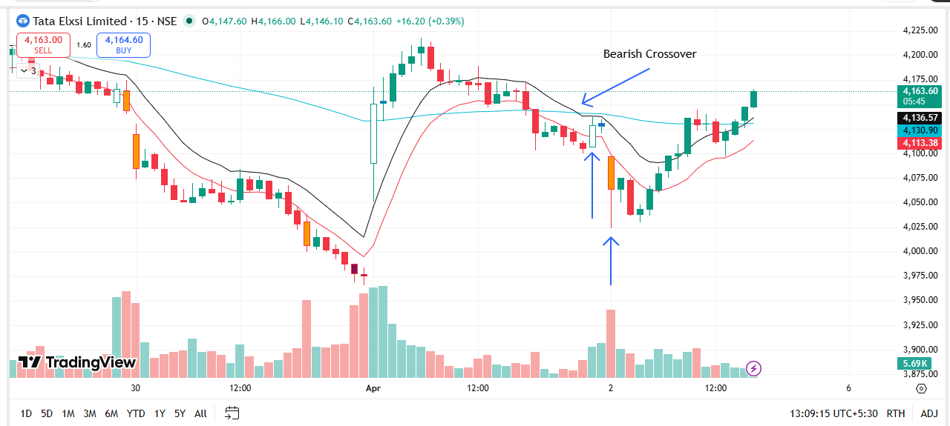
🔴 BEARISH SIGNAL --- INDHOTEL

Nifty Bias : ⚠️ CHOPPY — Choppy ⚠️
Crossover : 2026-03-27 11:45 (6 days ago)
Pullback : 2026-04-01 15:15
High ₹587.6 ≥ EMA9(High) ₹586.96
Low ₹583.7 (breakdown level)
Confirm : 2026-04-02 09:15 (+1 candle)
Close ₹569.05 < Pullback Low ₹583.7 (body breakdown)
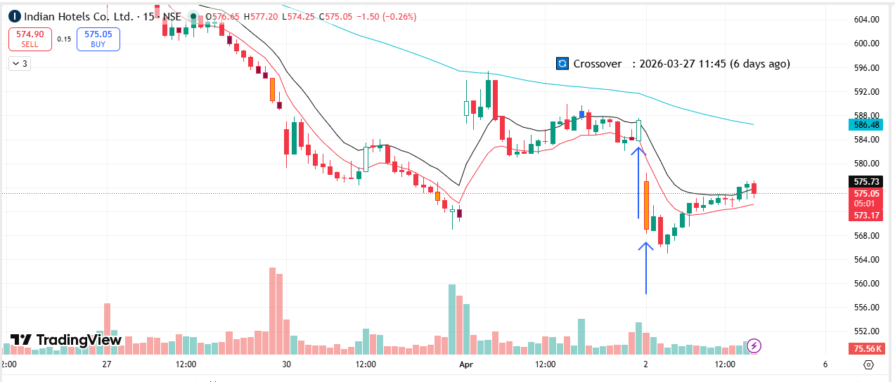
🔴 BEARISH SIGNAL --- TORNTPOWER

Nifty Bias : ⚠️ CHOPPY — Choppy ⚠️
Crossover : 2026-03-25 15:00 (8 days ago)
Pullback : 2026-04-01 15:15
High ₹1343.8 ≥ EMA9(High) ₹1342.24
Low ₹1333.5 (breakdown level)
Confirm : 2026-04-02 09:15 (+1 candle)
Close ₹1289.5 < Pullback Low ₹1333.5 (body breakdown)
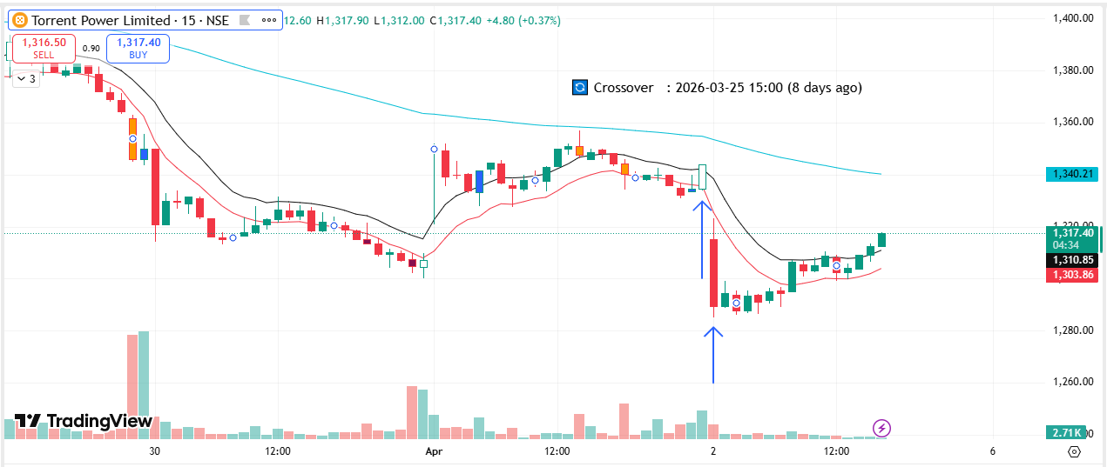
🔴 BEARISH SIGNAL --- UNOMINDA

Nifty Bias : ⚠️ CHOPPY — Choppy ⚠️
Crossover : 2026-04-01 14:00 (20 hours ago)
Pullback : 2026-04-01 15:15
High ₹1047.1 ≥ EMA9(High) ₹1046.6
Low ₹1035.8 (breakdown level)
Confirm : 2026-04-02 09:15 (+1 candle)
Close ₹1012.8 < Pullback Low ₹1035.8 (body breakdown)
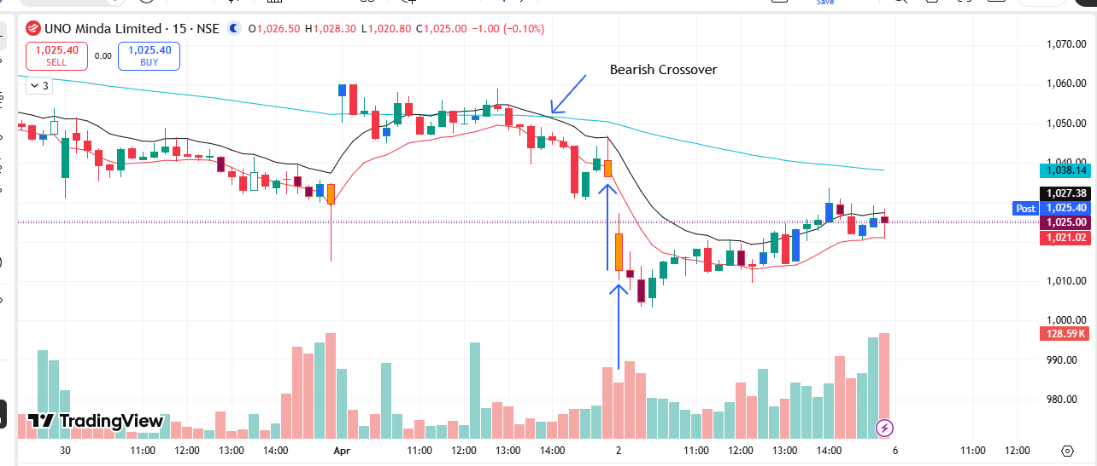
🔴 BEARISH SIGNAL --- UPL

Nifty Bias : ⚠️ CHOPPY — Choppy ⚠️
Crossover : 2026-04-01 15:00 (19 hours ago)
Pullback : 2026-04-01 15:15
High ₹598.2 ≥ EMA9(High) ₹597.93
Low ₹593.15 (breakdown level)
Confirm : 2026-04-02 09:15 (+1 candle)
Close ₹579.8 < Pullback Low ₹593.15 (body breakdown)
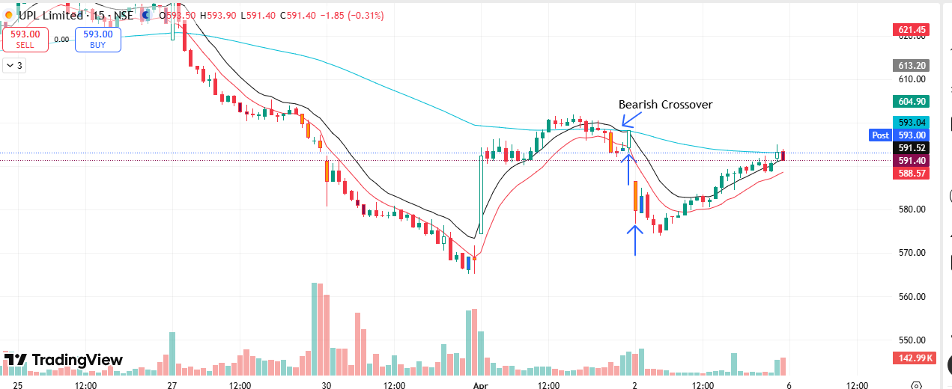
🔴 BEARISH SIGNAL --- UNITDSPR

Nifty Bias : ⚠️ CHOPPY — Choppy ⚠️
Crossover : 2026-03-27 10:00 (6 days ago)
Pullback : 2026-04-01 15:00
High ₹1250.3 ≥ EMA9(High) ₹1249.15
Low ₹1243.5 (breakdown level)
Confirm : 2026-04-02 09:15 (+2 candle)
Close ₹1223.8 < Pullback Low ₹1243.5 (body breakdown)
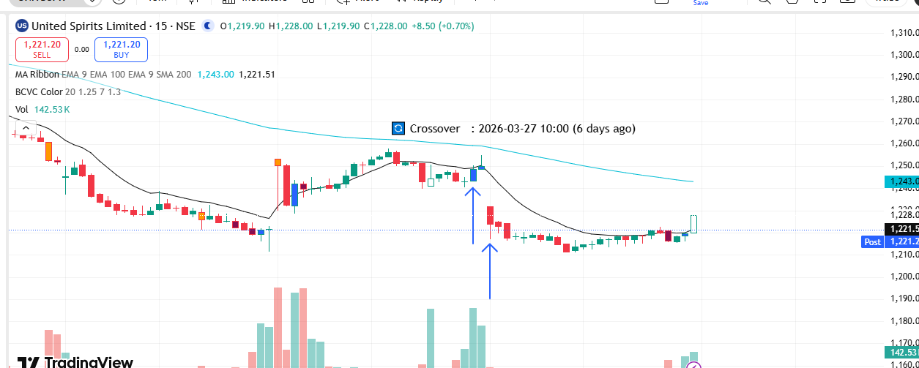
🔴 BEARISH SIGNAL --- VOLTAS

Nifty Bias : ⚠️ CHOPPY — Choppy ⚠️
Crossover : 2026-03-30 09:15 (3 days ago)
Pullback : 2026-04-01 14:45
High ₹1243.7 ≥ EMA9(High) ₹1241.46
Low ₹1228.7 (breakdown level)
Confirm : 2026-04-02 09:15 (+3 candle)
Close ₹1198.6 < Pullback Low ₹1228.7 (body breakdown)
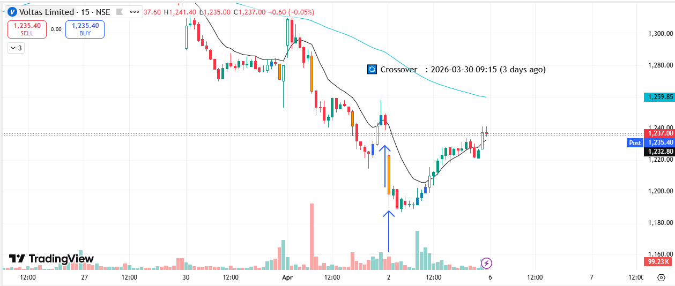
🟢 BULLISH SIGNAL --- DIXON

Nifty Bias : 🔴 SHORT — Counter Trend ⚠️
Crossover : 2026-04-01 12:30 (21 hours ago)
Pullback : 2026-04-02 09:15
Low ₹9940 ≤ EMA9(Low) ₹10172.06
High ₹10138.5 (breakout level)
Confirm : 2026-04-02 09:30 (+1 candle)
Close ₹10146 > Pullback High ₹10138.5 (body breakout)
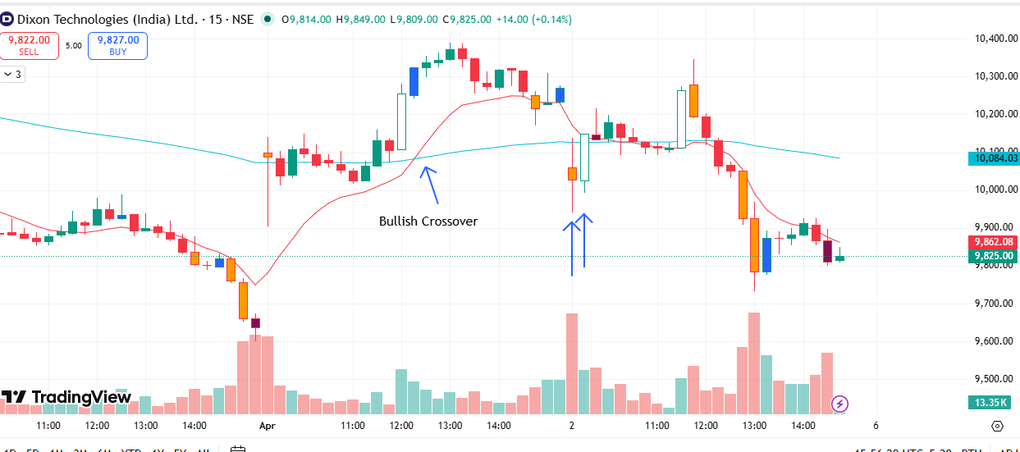
🟢 BULLISH SIGNAL --- KPITTECH

Nifty Bias : 🔴 SHORT — Counter Trend ⚠️
Crossover : 2026-04-01 10:30 (a day ago)
Pullback : 2026-04-02 09:15
Low ₹652.05 ≤ EMA9(Low) ₹666.81
High ₹667.5 (breakout level)
Confirm : 2026-04-02 09:30 (+1 candle)
Close ₹668 > Pullback High ₹667.5 (body breakout)
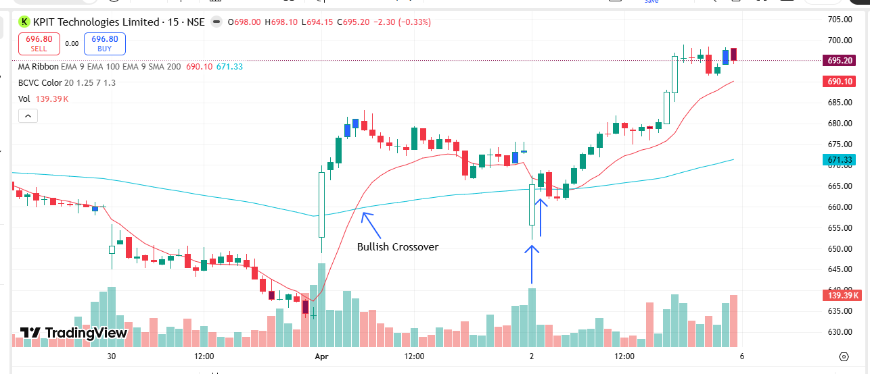
🟢 BULLISH SIGNAL --- VBL

Nifty Bias : 🔴 SHORT — Counter Trend ⚠️
Crossover : 2026-04-01 12:00 (a day ago)
Pullback : 2026-04-02 09:15
Low ₹390.6 ≤ EMA9(Low) ₹398.16
High ₹397.6 (breakout level)
Confirm : 2026-04-02 09:30 (+1 candle)
Close ₹397.65 > Pullback High ₹397.6 (body breakout)
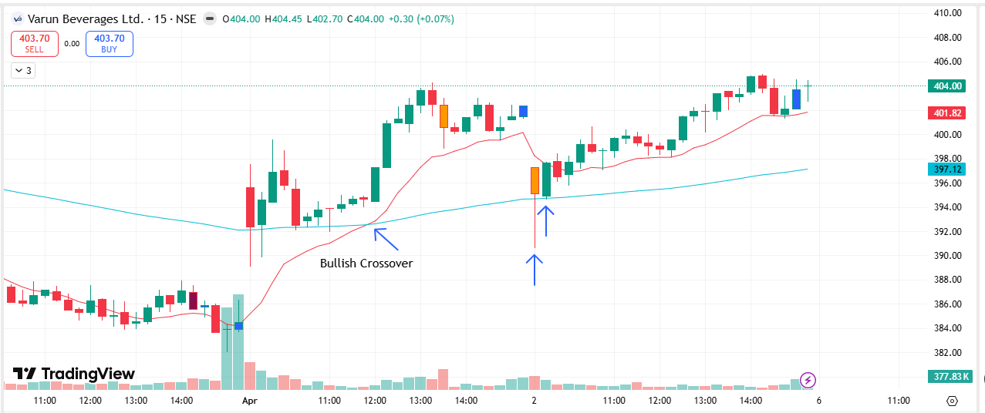
🟢 BULLISH SIGNAL --- ONGC

Nifty Bias : 🔴 SHORT — Counter Trend ⚠️
Crossover : 2026-03-25 10:30 (8 days ago)
Pullback : 2026-04-02 09:30
Low ₹283.5 ≤ EMA9(Low) ₹285.6
High ₹285.1 (breakout level)
Confirm : 2026-04-02 09:45 (+1 candle)
Close ₹285.25 > Pullback High ₹285.1 (body breakout)
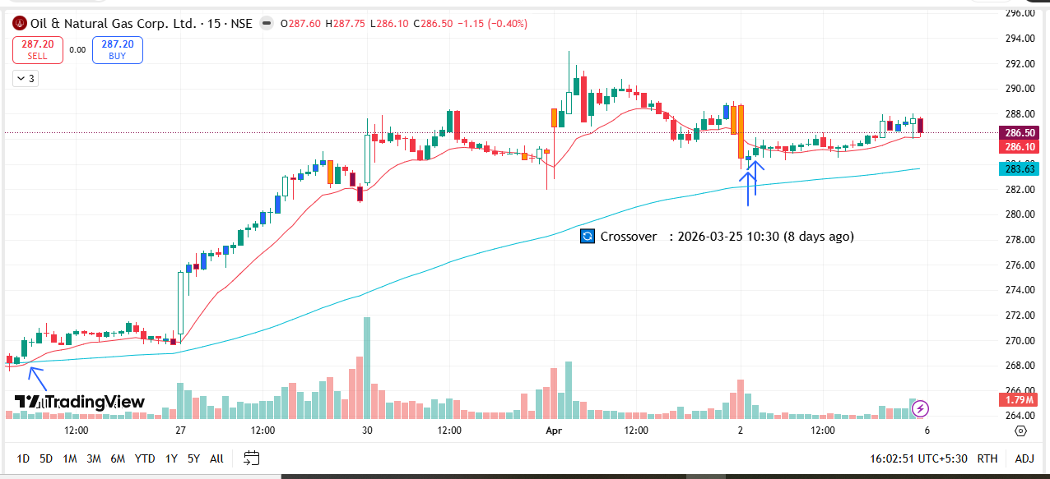
🟢 BULLISH SIGNAL --- DMART

Nifty Bias : 🔴 SHORT — Counter Trend ⚠️
Crossover : 2026-03-25 09:30 (8 days ago)
Pullback : 2026-04-02 10:00
Low ₹4235 ≤ EMA9(Low) ₹4249.34
High ₹4283 (breakout level)
Confirm : 2026-04-02 10:30 (+2 candle)
Close ₹4291 > Pullback High ₹4283 (body breakout)
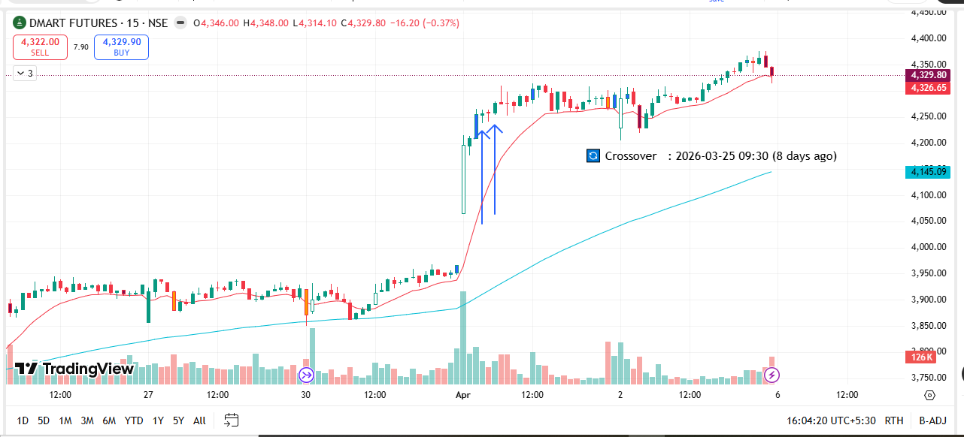
🟢 BULLISH SIGNAL --- BOSCHLTD

Nifty Bias : 🔴 SHORT — Counter Trend ⚠️
Crossover : 2026-04-01 10:30 (a day ago)
Pullback : 2026-04-02 09:45
Low ₹30130 ≤ EMA9(Low) ₹30296.9
High ₹30350 (breakout level)
Confirm : 2026-04-02 10:30 (+3 candle)
Close ₹30425 > Pullback High ₹30350 (body breakout)
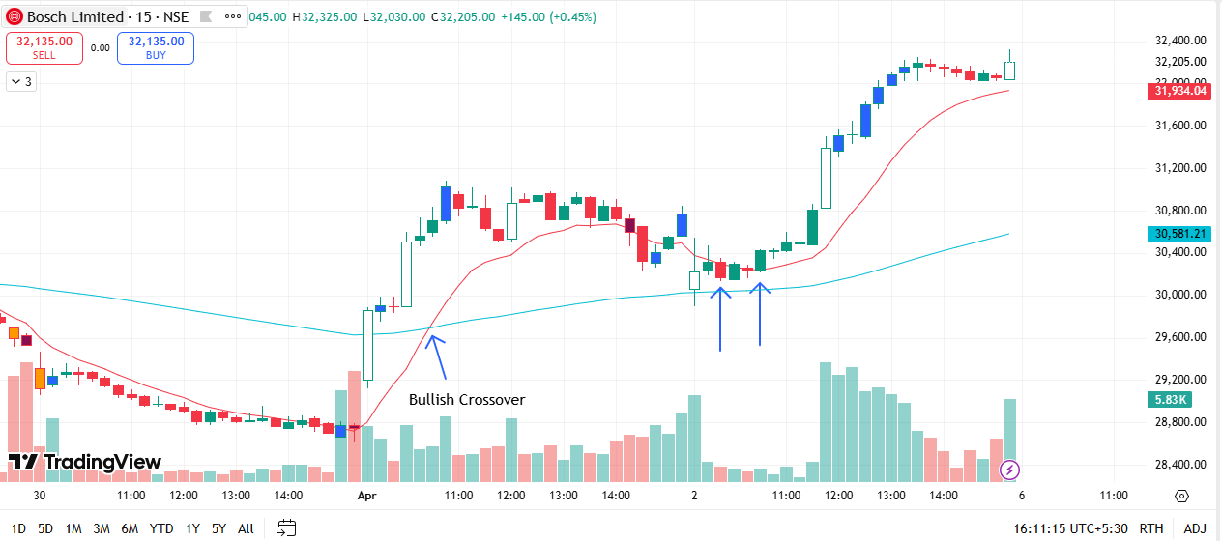
🟢 BULLISH SIGNAL --- PERSISTENT

Nifty Bias : 🔴 SHORT — Counter Trend ⚠️
Crossover : 2026-04-01 09:15 (a day ago)
Pullback : 2026-04-02 09:45
Low ₹4991.8 ≤ EMA9(Low) ₹5011.86
High ₹5038.1 (breakout level)
Confirm : 2026-04-02 10:30 (+3 candle)
Close ₹5041 > Pullback High ₹5038.1 (body breakout)
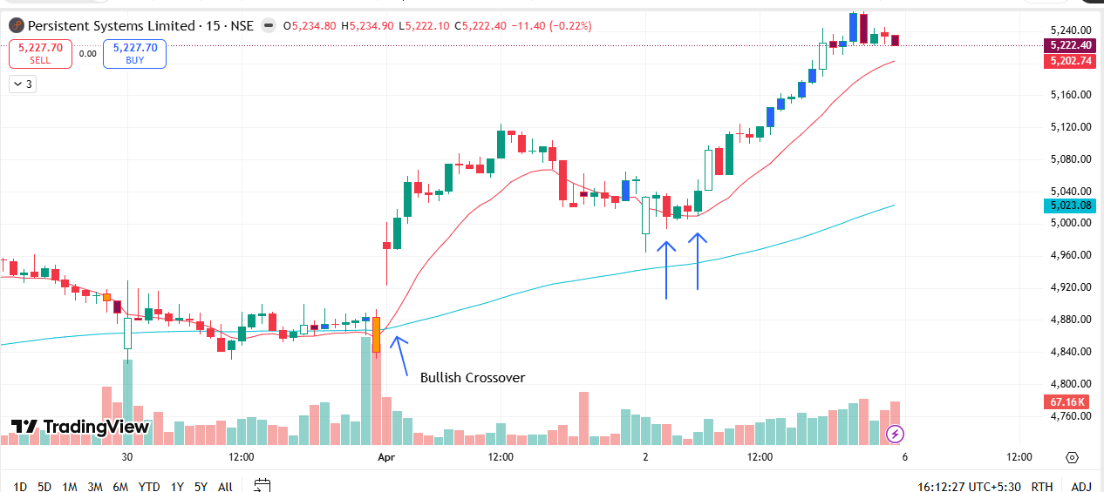
🟢 BULLISH SIGNAL --- NATIONALUM

Nifty Bias : 🔴 SHORT — Counter Trend ⚠️
Crossover : 2026-03-25 11:45 (8 days ago)
Pullback : 2026-04-02 10:45
Low ₹386.5 ≤ EMA9(Low) ₹389.47
High ₹387.8 (breakout level)
Confirm : 2026-04-02 11:00 (+1 candle)
Close ₹387.9 > Pullback High ₹387.8 (body breakout)
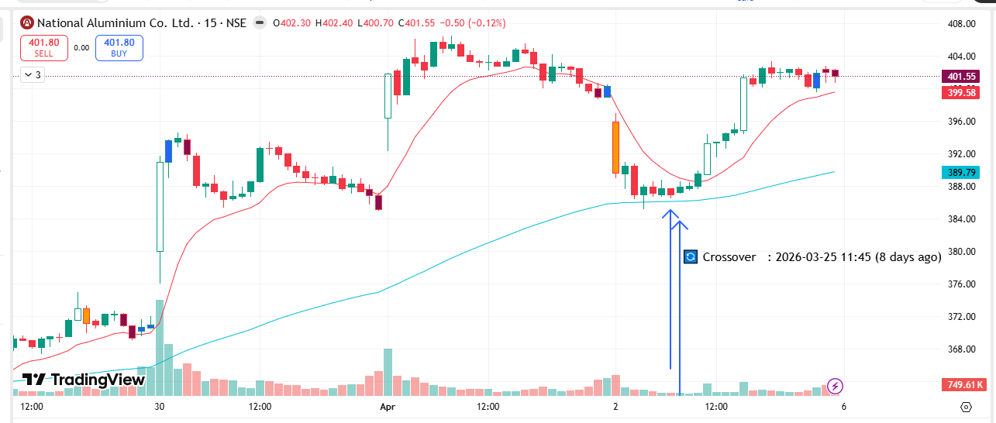
🔴 BEARISH SIGNAL --- INFY

Nifty Bias : 🔴 SHORT — Aligned ✅
Crossover : 2026-04-02 11:15 (an hour ago)
Pullback : 2026-04-02 11:30
High ₹1272.5 ≥ EMA9(High) ₹1272.23
Low ₹1268 (breakdown level)
Confirm : 2026-04-02 11:45 (+1 candle)
Close ₹1266.5 < Pullback Low ₹1268 (body breakdown)
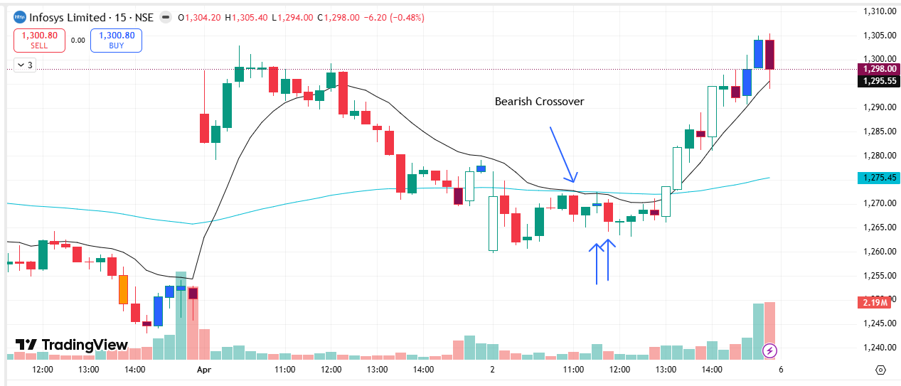
🔴 BEARISH SIGNAL --- ABCAPITAL

Nifty Bias : 🔴 SHORT — Aligned ✅
Crossover : 2026-04-02 09:30 (3 hours ago)
Pullback : 2026-04-02 11:45
High ₹292.4 ≥ EMA9(High) ₹292.04
Low ₹289.7 (breakdown level)
Confirm : 2026-04-02 12:00 (+1 candle)
Close ₹289.6 < Pullback Low ₹289.7 (body breakdown)
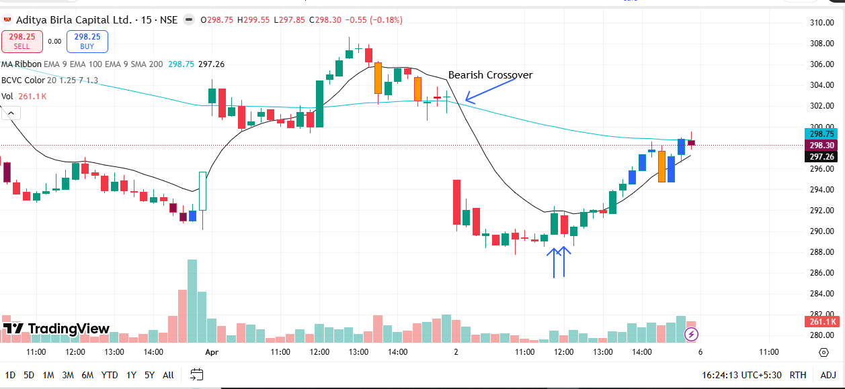
🔴 BEARISH SIGNAL --- GODREJPROP

Nifty Bias : 🔴 SHORT — Aligned ✅
Crossover : 2026-04-01 15:15 (21 hours ago)
Pullback : 2026-04-02 11:45
High ₹1474.9 ≥ EMA9(High) ₹1466.19
Low ₹1465.7 (breakdown level)
Confirm : 2026-04-02 12:00 (+1 candle)
Close ₹1464.6 < Pullback Low ₹1465.7 (body breakdown)
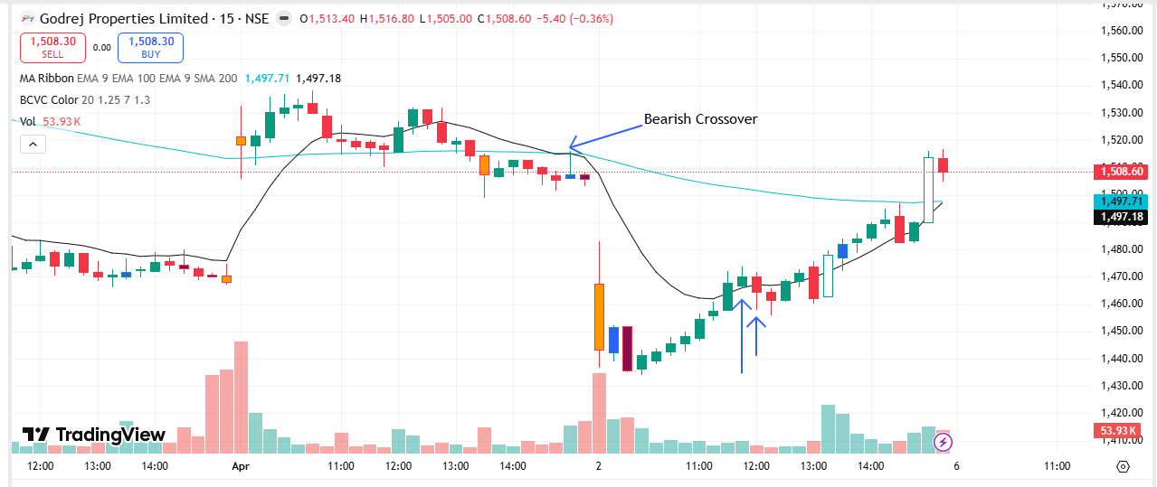
🔴 BEARISH SIGNAL --- IIFL

Nifty Bias : 🔴 SHORT — Aligned ✅
Crossover : 2026-03-27 09:45 (6 days ago)
Pullback : 2026-04-02 11:45
High ₹428.7 ≥ EMA9(High) ₹427.94
Low ₹424.45 (breakdown level)
Confirm : 2026-04-02 12:00 (+1 candle)
Close ₹422.45 < Pullback Low ₹424.45 (body breakdown)

🔴 BEARISH SIGNAL --- IRCTC

Nifty Bias : 🔴 SHORT — Aligned ✅
Crossover : 2026-04-02 09:15 (3 hours ago)
Pullback : 2026-04-02 11:30
High ₹504 ≥ EMA9(High) ₹503.78
Low ₹501.3 (breakdown level)
Confirm : 2026-04-02 12:00 (+2 candle)
Close ₹501.05 < Pullback Low ₹501.3 (body breakdown)

🔴 BEARISH SIGNAL --- IREDA

Nifty Bias : 🔴 SHORT — Aligned ✅
Crossover : 2026-04-02 09:15 (3 hours ago)
Pullback : 2026-04-02 11:45
High ₹112.12 ≥ EMA9(High) ₹111.6
Low ₹111.55 (breakdown level)
Confirm : 2026-04-02 12:00 (+1 candle)
Close ₹111.5 < Pullback Low ₹111.55 (body breakdown)
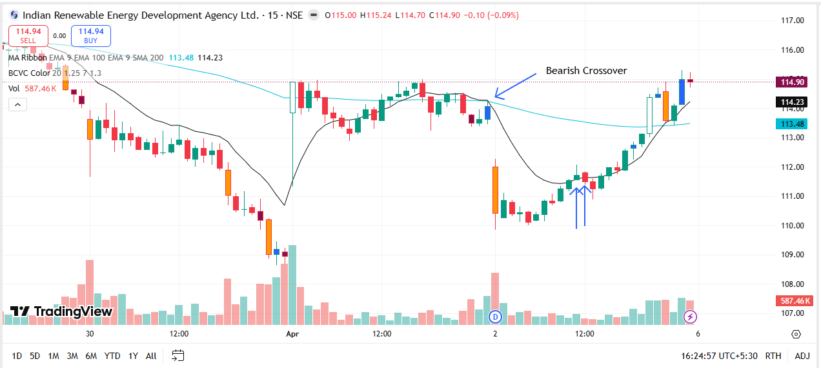
🔴 BEARISH SIGNAL --- NAUKRI

Nifty Bias : 🔴 SHORT — Aligned ✅
Crossover : 2026-04-02 09:45 (3 hours ago)
Pullback : 2026-04-02 11:30
High ₹981.65 ≥ EMA9(High) ₹976.14
Low ₹974.4 (breakdown level)
Confirm : 2026-04-02 12:00 (+2 candle)
Close ₹972.6 < Pullback Low ₹974.4 (body breakdown)

🔴 BEARISH SIGNAL --- INOXWIND

Nifty Bias : 🔴 SHORT — Aligned ✅
Crossover : 2026-04-02 10:00 (2 hours ago)
Pullback : 2026-04-02 11:45
High ₹77.94 ≥ EMA9(High) ₹77.86
Low ₹77.53 (breakdown level)
Confirm : 2026-04-02 12:00 (+1 candle)
Close ₹77.39 < Pullback Low ₹77.53 (body breakdown)

🔴 BEARISH SIGNAL --- INDIGO

Nifty Bias : 🔴 SHORT — Aligned ✅
Crossover : 2026-04-02 09:45 (3 hours ago)
Pullback : 2026-04-02 11:45
High ₹4058.4 ≥ EMA9(High) ₹4051.05
Low ₹4040.6 (breakdown level)
Confirm : 2026-04-02 12:00 (+1 candle)
Close ₹4035 < Pullback Low ₹4040.6 (body breakdown)

🔴 BEARISH SIGNAL --- RVNL

Nifty Bias : 🔴 SHORT — Aligned ✅
Crossover : 2026-04-02 09:30 (3 hours ago)
Pullback : 2026-04-02 11:45
High ₹254.9 ≥ EMA9(High) ₹254.43
Low ₹253.84 (breakdown level)
Confirm : 2026-04-02 12:00 (+1 candle)
Close ₹253.81 < Pullback Low ₹253.84 (body breakdown)

🔴 BEARISH SIGNAL --- SUZLON

Nifty Bias : 🔴 SHORT — Aligned ✅
Crossover : 2026-04-02 09:30 (3 hours ago)
Pullback : 2026-04-02 11:30
High ₹40.18 ≥ EMA9(High) ₹40.17
Low ₹40 (breakdown level)
Confirm : 2026-04-02 12:00 (+2 candle)
Close ₹39.99 < Pullback Low ₹40 (body breakdown)

🔴 BEARISH SIGNAL --- ADANIENT

Nifty Bias : 🔴 SHORT — Aligned ✅
Crossover : 2026-04-02 09:30 (3 hours ago)
Pullback : 2026-04-02 11:45
High ₹1802.9 ≥ EMA9(High) ₹1799.11
Low ₹1790.3 (breakdown level)
Confirm : 2026-04-02 12:15 (+2 candle)
Close ₹1786.4 < Pullback Low ₹1790.3 (body breakdown)

🔴 BEARISH SIGNAL --- BHEL

Nifty Bias : 🔴 SHORT — Aligned ✅
Crossover : 2026-04-01 14:30 (a day ago)
Pullback : 2026-04-02 11:45
High ₹245.25 ≥ EMA9(High) ₹244.93
Low ₹243.93 (breakdown level)
Confirm : 2026-04-02 12:15 (+2 candle)
Close ₹243.85 < Pullback Low ₹243.93 (body breakdown)

🔴 BEARISH SIGNAL --- BIOCON

Nifty Bias : 🔴 SHORT — Aligned ✅
Crossover : 2026-04-01 14:15 (a day ago)
Pullback : 2026-04-02 11:45
High ₹352.75 ≥ EMA9(High) ₹351.01
Low ₹351.25 (breakdown level)
Confirm : 2026-04-02 12:15 (+2 candle)
Close ₹350.35 < Pullback Low ₹351.25 (body breakdown)

🔴 BEARISH SIGNAL --- CGPOWER

Nifty Bias : 🔴 SHORT — Aligned ✅
Crossover : 2026-04-02 10:00 (3 hours ago)
Pullback : 2026-04-02 11:45
High ₹669.95 ≥ EMA9(High) ₹666.23
Low ₹666.6 (breakdown level)
Confirm : 2026-04-02 12:15 (+2 candle)
Close ₹666.35 < Pullback Low ₹666.6 (body breakdown)

🔴 BEARISH SIGNAL --- CROMPTON

Nifty Bias : 🔴 SHORT — Aligned ✅
Crossover : 2026-04-02 09:15 (3 hours ago)
Pullback : 2026-04-02 11:45
High ₹229.5 ≥ EMA9(High) ₹228.39
Low ₹228.38 (breakdown level)
Confirm : 2026-04-02 12:15 (+2 candle)
Close ₹228.1 < Pullback Low ₹228.38 (body breakdown)

🔴 BEARISH SIGNAL --- GLENMARK

Nifty Bias : 🔴 SHORT — Aligned ✅
Crossover : 2026-04-01 13:30 (a day ago)
Pullback : 2026-04-02 11:45
High ₹2056 ≥ EMA9(High) ₹2038.18
Low ₹2048.7 (breakdown level)
Confirm : 2026-04-02 12:15 (+2 candle)
Close ₹2044.9 < Pullback Low ₹2048.7 (body breakdown)

🔴 BEARISH SIGNAL --- GRASIM

Nifty Bias : 🔴 SHORT — Aligned ✅
Crossover : 2026-04-02 09:15 (3 hours ago)
Pullback : 2026-04-02 12:00
High ₹2540.3 ≥ EMA9(High) ₹2538.88
Low ₹2531 (breakdown level)
Confirm : 2026-04-02 12:15 (+1 candle)
Close ₹2530 < Pullback Low ₹2531 (body breakdown)

🔴 BEARISH SIGNAL --- HUDCO

Nifty Bias : 🔴 SHORT — Aligned ✅
Crossover : 2026-04-02 09:30 (3 hours ago)
Pullback : 2026-04-02 11:30
High ₹163.83 ≥ EMA9(High) ₹163.77
Low ₹163.1 (breakdown level)
Confirm : 2026-04-02 12:15 (+3 candle)
Close ₹163.02 < Pullback Low ₹163.1 (body breakdown)

🔴 BEARISH SIGNAL --- IEX

Nifty Bias : 🔴 SHORT — Aligned ✅
Crossover : 2026-04-02 09:45 (3 hours ago)
Pullback : 2026-04-02 11:30
High ₹118.25 ≥ EMA9(High) ₹118.08
Low ₹117.91 (breakdown level)
Confirm : 2026-04-02 12:15 (+3 candle)
Close ₹117.87 < Pullback Low ₹117.91 (body breakdown)

🔴 BEARISH SIGNAL --- IRFC

Nifty Bias : 🔴 SHORT — Aligned ✅
Crossover : 2026-04-02 09:30 (3 hours ago)
Pullback : 2026-04-02 11:45
High ₹90.4 ≥ EMA9(High) ₹90.05
Low ₹89.99 (breakdown level)
Confirm : 2026-04-02 12:15 (+2 candle)
Close ₹89.69 < Pullback Low ₹89.99 (body breakdown)

🔴 BEARISH SIGNAL --- LICI

Nifty Bias : 🔴 SHORT — Aligned ✅
Crossover : 2026-04-01 14:30 (a day ago)
Pullback : 2026-04-02 11:45
High ₹729.7 ≥ EMA9(High) ₹729.28
Low ₹727.25 (breakdown level)
Confirm : 2026-04-02 12:15 (+2 candle)
Close ₹726.9 < Pullback Low ₹727.25 (body breakdown)

🔴 BEARISH SIGNAL --- NBCC

Nifty Bias : 🔴 SHORT — Aligned ✅
Crossover : 2026-04-02 10:00 (3 hours ago)
Pullback : 2026-04-02 11:45
High ₹80.98 ≥ EMA9(High) ₹80.66
Low ₹80.51 (breakdown level)
Confirm : 2026-04-02 12:15 (+2 candle)
Close ₹80.46 < Pullback Low ₹80.51 (body breakdown)

🔴 BEARISH SIGNAL --- PPLPHARMA

Nifty Bias : 🔴 SHORT — Aligned ✅
Crossover : 2026-04-02 09:45 (3 hours ago)
Pullback : 2026-04-02 12:00
High ₹139.65 ≥ EMA9(High) ₹138.98
Low ₹139.09 (breakdown level)
Confirm : 2026-04-02 12:15 (+1 candle)
Close ₹138.75 < Pullback Low ₹139.09 (body breakdown)

🔴 BEARISH SIGNAL --- PFC

Nifty Bias : 🔴 SHORT — Aligned ✅
Crossover : 2026-04-02 09:30 (3 hours ago)
Pullback : 2026-04-02 12:00
High ₹393 ≥ EMA9(High) ₹391.22
Low ₹391.1 (breakdown level)
Confirm : 2026-04-02 12:15 (+1 candle)
Close ₹390.7 < Pullback Low ₹391.1 (body breakdown)

🔴 BEARISH SIGNAL --- SUNPHARMA

Nifty Bias : 🔴 SHORT — Aligned ✅
Crossover : 2026-03-30 10:45 (3 days ago)
Pullback : 2026-04-02 12:00
High ₹1695.4 ≥ EMA9(High) ₹1685.15
Low ₹1685.3 (breakdown level)
Confirm : 2026-04-02 12:15 (+1 candle)
Close ₹1683.2 < Pullback Low ₹1685.3 (body breakdown)

🔴 BEARISH SIGNAL --- TATATECH

Nifty Bias : 🔴 SHORT — Aligned ✅
Crossover : 2026-04-02 09:30 (3 hours ago)
Pullback : 2026-04-02 11:45
High ₹530 ≥ EMA9(High) ₹527.11
Low ₹528.35 (breakdown level)
Confirm : 2026-04-02 12:15 (+2 candle)
Close ₹528.05 < Pullback Low ₹528.35 (body breakdown)

🔴 BEARISH SIGNAL --- PHOENIXLTD

Nifty Bias : 🔴 SHORT — Aligned ✅
Crossover : 2026-04-02 09:15 (3 hours ago)
Pullback : 2026-04-02 11:45
High ₹1512.8 ≥ EMA9(High) ₹1502.71
Low ₹1505.6 (breakdown level)
Confirm : 2026-04-02 12:15 (+2 candle)
Close ₹1505.1 < Pullback Low ₹1505.6 (body breakdown)

🔴 BEARISH SIGNAL --- ULTRACEMCO

Nifty Bias : 🔴 SHORT — Aligned ✅
Crossover : 2026-03-30 11:00 (3 days ago)
Pullback : 2026-04-02 11:45
High ₹10504 ≥ EMA9(High) ₹10501.28
Low ₹10456 (breakdown level)
Confirm : 2026-04-02 12:15 (+2 candle)
Close ₹10455 < Pullback Low ₹10456 (body breakdown)

🔴 BEARISH SIGNAL --- APOLLOHOSP

Nifty Bias : 🔴 SHORT — Aligned ✅
Crossover : 2026-04-01 10:45 (a day ago)
Pullback : 2026-04-02 12:00
High ₹7276.5 ≥ EMA9(High) ₹7239.24
Low ₹7256 (breakdown level)
Confirm : 2026-04-02 12:30 (+2 candle)
Close ₹7249 < Pullback Low ₹7256 (body breakdown)

🔴 BEARISH SIGNAL --- FORTIS

Nifty Bias : 🔴 SHORT — Aligned ✅
Crossover : 2026-03-30 09:15 (3 days ago)
Pullback : 2026-04-02 12:00
High ₹787.95 ≥ EMA9(High) ₹782.28
Low ₹783.6 (breakdown level)
Confirm : 2026-04-02 12:30 (+2 candle)
Close ₹782.85 < Pullback Low ₹783.6 (body breakdown)

🔴 BEARISH SIGNAL --- POWERINDIA

Nifty Bias : 🔴 SHORT — Aligned ✅
Crossover : 2026-04-02 10:00 (3 hours ago)
Pullback : 2026-04-02 12:00
High ₹24690 ≥ EMA9(High) ₹24562.47
Low ₹24540 (breakdown level)
Confirm : 2026-04-02 12:30 (+2 candle)
Close ₹24515 < Pullback Low ₹24540 (body breakdown)

🔴 BEARISH SIGNAL --- NUVAMA

Nifty Bias : 🔴 SHORT — Aligned ✅
Crossover : 2026-04-01 10:45 (a day ago)
Pullback : 2026-04-02 11:45
High ₹1134.8 ≥ EMA9(High) ₹1128.86
Low ₹1129.4 (breakdown level)
Confirm : 2026-04-02 12:30 (+3 candle)
Close ₹1127.8 < Pullback Low ₹1129.4 (body breakdown)

🔴 BEARISH SIGNAL --- TORNTPHARM

Nifty Bias : 🔴 SHORT — Aligned ✅
Crossover : 2026-04-01 11:00 (a day ago)
Pullback : 2026-04-02 11:45
High ₹3991.1 ≥ EMA9(High) ₹3983.16
Low ₹3976.1 (breakdown level)
Confirm : 2026-04-02 12:30 (+3 candle)
Close ₹3970.2 < Pullback Low ₹3976.1 (body breakdown)

🔴 BEARISH SIGNAL --- AMBER

Nifty Bias : ⚠️ CHOPPY — Choppy ⚠️
Crossover : 2026-04-02 09:30 (4 hours ago)
Pullback : 2026-04-02 12:30
High ₹6323.5 ≥ EMA9(High) ₹6318.1
Low ₹6304.5 (breakdown level)
Confirm : 2026-04-02 12:45 (+1 candle)
Close ₹6304 < Pullback Low ₹6304.5 (body breakdown)

🔴 BEARISH SIGNAL --- BHARTIARTL

Nifty Bias : ⚠️ CHOPPY — Choppy ⚠️
Crossover : 2026-03-30 10:15 (3 days ago)
Pullback : 2026-04-02 12:30
High ₹1761.4 ≥ EMA9(High) ₹1761
Low ₹1755.1 (breakdown level)
Confirm : 2026-04-02 12:45 (+1 candle)
Close ₹1753.8 < Pullback Low ₹1755.1 (body breakdown)

🔴 BEARISH SIGNAL --- CIPLA

Nifty Bias : ⚠️ CHOPPY — Choppy ⚠️
Crossover : 2026-03-30 09:15 (3 days ago)
Pullback : 2026-04-02 12:30
High ₹1188 ≥ EMA9(High) ₹1186.52
Low ₹1185.3 (breakdown level)
Confirm : 2026-04-02 12:45 (+1 candle)
Close ₹1185.1 < Pullback Low ₹1185.3 (body breakdown)

🔴 BEARISH SIGNAL --- MCX

Nifty Bias : ⚠️ CHOPPY — Choppy ⚠️
Crossover : 2026-04-02 10:00 (3 hours ago)
Pullback : 2026-04-02 12:30
High ₹2433.5 ≥ EMA9(High) ₹2414.55
Low ₹2419.1 (breakdown level)
Confirm : 2026-04-02 12:45 (+1 candle)
Close ₹2417.2 < Pullback Low ₹2419.1 (body breakdown)

🔴 BEARISH SIGNAL --- POLICYBZR

Nifty Bias : ⚠️ CHOPPY — Choppy ⚠️
Crossover : 2026-04-01 14:45 (a day ago)
Pullback : 2026-04-02 12:30
High ₹1419 ≥ EMA9(High) ₹1416.02
Low ₹1415.1 (breakdown level)
Confirm : 2026-04-02 12:45 (+1 candle)
Close ₹1414.4 < Pullback Low ₹1415.1 (body breakdown)

🔴 BEARISH SIGNAL --- BHARATFORG

Nifty Bias : ⚠️ CHOPPY — Choppy ⚠️
Crossover : 2026-04-01 14:30 (a day ago)
Pullback : 2026-04-02 12:30
High ₹1647.8 ≥ EMA9(High) ₹1640.37
Low ₹1638.6 (breakdown level)
Confirm : 2026-04-02 13:00 (+2 candle)
Close ₹1631.7 < Pullback Low ₹1638.6 (body breakdown)

🔴 BEARISH SIGNAL --- DLF

Nifty Bias : ⚠️ CHOPPY — Choppy ⚠️
Crossover : 2026-03-27 09:45 (6 days ago)
Pullback : 2026-04-02 12:45
High ₹510.25 ≥ EMA9(High) ₹505.48
Low ₹508.25 (breakdown level)
Confirm : 2026-04-02 13:00 (+1 candle)
Close ₹508.2 < Pullback Low ₹508.25 (body breakdown)

🔴 BEARISH SIGNAL --- DRREDDY

Nifty Bias : ⚠️ CHOPPY — Choppy ⚠️
Crossover : 2026-03-30 09:45 (3 days ago)
Pullback : 2026-04-02 12:45
High ₹1219.7 ≥ EMA9(High) ₹1212.31
Low ₹1215.1 (breakdown level)
Confirm : 2026-04-02 13:00 (+1 candle)
Close ₹1214.3 < Pullback Low ₹1215.1 (body breakdown)

🔴 BEARISH SIGNAL --- KEI

Nifty Bias : ⚠️ CHOPPY — Choppy ⚠️
Crossover : 2026-04-02 09:30 (4 hours ago)
Pullback : 2026-04-02 12:15
High ₹4059.5 ≥ EMA9(High) ₹4028.29
Low ₹4027.5 (breakdown level)
Confirm : 2026-04-02 13:00 (+3 candle)
Close ₹4025 < Pullback Low ₹4027.5 (body breakdown)

🔴 BEARISH SIGNAL --- KAYNES

Nifty Bias : ⚠️ CHOPPY — Choppy ⚠️
Crossover : 2026-04-01 15:15 (a day ago)
Pullback : 2026-04-02 12:30
High ₹3473.9 ≥ EMA9(High) ₹3461.19
Low ₹3453.5 (breakdown level)
Confirm : 2026-04-02 13:00 (+2 candle)
Close ₹3445.9 < Pullback Low ₹3453.5 (body breakdown)

🔴 BEARISH SIGNAL --- NHPC

Nifty Bias : ⚠️ CHOPPY — Choppy ⚠️
Crossover : 2026-03-30 09:15 (3 days ago)
Pullback : 2026-04-02 12:45
High ₹74.85 ≥ EMA9(High) ₹74.52
Low ₹74.67 (breakdown level)
Confirm : 2026-04-02 13:00 (+1 candle)
Close ₹74.4 < Pullback Low ₹74.67 (body breakdown)

🔴 BEARISH SIGNAL --- PAYTM

Nifty Bias : ⚠️ CHOPPY — Choppy ⚠️
Crossover : 2026-03-27 11:15 (6 days ago)
Pullback : 2026-04-02 12:30
High ₹990.4 ≥ EMA9(High) ₹983.14
Low ₹984.6 (breakdown level)
Confirm : 2026-04-02 13:00 (+2 candle)
Close ₹983.25 < Pullback Low ₹984.6 (body breakdown)

🔴 BEARISH SIGNAL --- 360ONE

Nifty Bias : 🟢 LONG — Counter Trend ⚠️
Crossover : 2026-03-20 14:45 (13 days ago)
Pullback : 2026-04-02 13:00
High ₹938.05 ≥ EMA9(High) ₹932.27
Low ₹933.65 (breakdown level)
Confirm : 2026-04-02 13:15 (+1 candle)
Close ₹933.45 < Pullback Low ₹933.65 (body breakdown)

🔴 BEARISH SIGNAL --- SRF

Nifty Bias : 🟢 LONG — Counter Trend ⚠️
Crossover : 2026-04-02 10:00 (4 hours ago)
Pullback : 2026-04-02 13:15
High ₹2428.5 ≥ EMA9(High) ₹2428.2
Low ₹2420 (breakdown level)
Confirm : 2026-04-02 13:30 (+1 candle)
Close ₹2417.5 < Pullback Low ₹2420 (body breakdown)

🔴 BEARISH SIGNAL --- ASIANPAINT

Nifty Bias : 🟢 LONG — Counter Trend ⚠️
Crossover : 2026-04-02 09:30 (5 hours ago)
Pullback : 2026-04-02 13:30
High ₹2165.8 ≥ EMA9(High) ₹2164.94
Low ₹2156.1 (breakdown level)
Confirm : 2026-04-02 13:45 (+1 candle)
Close ₹2155.8 < Pullback Low ₹2156.1 (body breakdown)

🔴 BEARISH SIGNAL --- INDUSTOWER

Nifty Bias : 🟢 LONG — Counter Trend ⚠️
Crossover : 2026-04-02 09:15 (5 hours ago)
Pullback : 2026-04-02 13:30
High ₹419.9 ≥ EMA9(High) ₹418.03
Low ₹418.25 (breakdown level)
Confirm : 2026-04-02 13:45 (+1 candle)
Close ₹418.1 < Pullback Low ₹418.25 (body breakdown)

🔴 BEARISH SIGNAL --- PIDILITIND

Nifty Bias : 🟢 LONG — Counter Trend ⚠️
Crossover : 2026-04-01 14:45 (a day ago)
Pullback : 2026-04-02 13:30
High ₹1279.2 ≥ EMA9(High) ₹1277.36
Low ₹1275 (breakdown level)
Confirm : 2026-04-02 13:45 (+1 candle)
Close ₹1273.2 < Pullback Low ₹1275 (body breakdown)

🔴 BEARISH SIGNAL --- IDEA

Nifty Bias : 🟢 LONG — Counter Trend ⚠️
Crossover : 2026-03-27 10:00 (6 days ago)
Pullback : 2026-04-02 13:00
High ₹8.45 ≥ EMA9(High) ₹8.39
Low ₹8.4 (breakdown level)
Confirm : 2026-04-02 13:45 (+3 candle)
Close ₹8.37 < Pullback Low ₹8.4 (body breakdown)

🔴 BEARISH SIGNAL --- MUTHOOTFIN

Nifty Bias : 🟢 LONG — Counter Trend ⚠️
Crossover : 2026-04-02 10:00 (5 hours ago)
Pullback : 2026-04-02 13:45
High ₹3188.9 ≥ EMA9(High) ₹3185.9
Low ₹3180 (breakdown level)
Confirm : 2026-04-02 14:15 (+2 candle)
Close ₹3178.5 < Pullback Low ₹3180 (body breakdown)

🔴 BEARISH SIGNAL --- APLAPOLLO

Nifty Bias : 🟢 LONG — Counter Trend ⚠️
Crossover : 2026-04-01 14:30 (a day ago)
Pullback : 2026-04-02 13:45
High ₹1888 ≥ EMA9(High) ₹1885.52
Low ₹1881.7 (breakdown level)
Confirm : 2026-04-02 14:30 (+3 candle)
Close ₹1877.1 < Pullback Low ₹1881.7 (body breakdown)

🔴 BEARISH SIGNAL --- AUBANK

Nifty Bias : 🟢 LONG — Counter Trend ⚠️
Crossover : 2026-04-02 09:30 (5 hours ago)
Pullback : 2026-04-02 14:15
High ₹863.4 ≥ EMA9(High) ₹854.85
Low ₹859.75 (breakdown level)
Confirm : 2026-04-02 14:30 (+1 candle)
Close ₹858.4 < Pullback Low ₹859.75 (body breakdown)

🔴 BEARISH SIGNAL --- ADANIENSOL

Nifty Bias : 🟢 LONG — Counter Trend ⚠️
Crossover : 2026-04-02 09:15 (6 hours ago)
Pullback : 2026-04-02 14:15
High ₹929.8 ≥ EMA9(High) ₹924.31
Low ₹926.25 (breakdown level)
Confirm : 2026-04-02 14:30 (+1 candle)
Close ₹925 < Pullback Low ₹926.25 (body breakdown)

🔴 BEARISH SIGNAL --- ASHOKLEY

Nifty Bias : 🟢 LONG — Counter Trend ⚠️
Crossover : 2026-03-27 10:00 (6 days ago)
Pullback : 2026-04-02 14:15
High ₹148.32 ≥ EMA9(High) ₹146.67
Low ₹147.46 (breakdown level)
Confirm : 2026-04-02 14:30 (+1 candle)
Close ₹147.27 < Pullback Low ₹147.46 (body breakdown)

🔴 BEARISH SIGNAL --- ASTRAL

Nifty Bias : 🟢 LONG — Counter Trend ⚠️
Crossover : 2026-04-01 11:30 (a day ago)
Pullback : 2026-04-02 14:15
High ₹1535 ≥ EMA9(High) ₹1525.24
Low ₹1527.7 (breakdown level)
Confirm : 2026-04-02 14:30 (+1 candle)
Close ₹1524.4 < Pullback Low ₹1527.7 (body breakdown)

🔴 BEARISH SIGNAL --- BAJAJ-AUTO

Nifty Bias : 🟢 LONG — Counter Trend ⚠️
Crossover : 2026-04-02 09:15 (6 hours ago)
Pullback : 2026-04-02 14:15
High ₹8824 ≥ EMA9(High) ₹8769.91
Low ₹8791.5 (breakdown level)
Confirm : 2026-04-02 14:30 (+1 candle)
Close ₹8778 < Pullback Low ₹8791.5 (body breakdown)

🔴 BEARISH SIGNAL --- BAJAJFINSV

Nifty Bias : 🟢 LONG — Counter Trend ⚠️
Crossover : 2026-03-27 10:45 (6 days ago)
Pullback : 2026-04-02 13:45
High ₹1633.3 ≥ EMA9(High) ₹1624.49
Low ₹1627.3 (breakdown level)
Confirm : 2026-04-02 14:30 (+3 candle)
Close ₹1619.5 < Pullback Low ₹1627.3 (body breakdown)

🔴 BEARISH SIGNAL --- BANDHANBNK

Nifty Bias : 🟢 LONG — Counter Trend ⚠️
Crossover : 2026-04-02 09:15 (6 hours ago)
Pullback : 2026-04-02 14:15
High ₹146.46 ≥ EMA9(High) ₹144.38
Low ₹145.39 (breakdown level)
Confirm : 2026-04-02 14:30 (+1 candle)
Close ₹144.87 < Pullback Low ₹145.39 (body breakdown)

🔴 BEARISH SIGNAL --- BANKINDIA

Nifty Bias : 🟢 LONG — Counter Trend ⚠️
Crossover : 2026-03-27 09:45 (6 days ago)
Pullback : 2026-04-02 14:15
High ₹138.58 ≥ EMA9(High) ₹137.5
Low ₹137.93 (breakdown level)
Confirm : 2026-04-02 14:30 (+1 candle)
Close ₹137.45 < Pullback Low ₹137.93 (body breakdown)

🔴 BEARISH SIGNAL --- BPCL

Nifty Bias : 🟢 LONG — Counter Trend ⚠️
Crossover : 2026-04-02 09:15 (6 hours ago)
Pullback : 2026-04-02 14:15
High ₹277.6 ≥ EMA9(High) ₹275.53
Low ₹276.7 (breakdown level)
Confirm : 2026-04-02 14:30 (+1 candle)
Close ₹276.25 < Pullback Low ₹276.7 (body breakdown)

🔴 BEARISH SIGNAL --- CONCOR

Nifty Bias : 🟢 LONG — Counter Trend ⚠️
Crossover : 2026-04-02 10:15 (5 hours ago)
Pullback : 2026-04-02 14:15
High ₹438 ≥ EMA9(High) ₹436.1
Low ₹436.25 (breakdown level)
Confirm : 2026-04-02 14:30 (+1 candle)
Close ₹435.7 < Pullback Low ₹436.25 (body breakdown)

🔴 BEARISH SIGNAL --- DABUR

Nifty Bias : 🟢 LONG — Counter Trend ⚠️
Crossover : 2026-03-27 10:00 (6 days ago)
Pullback : 2026-04-02 14:15
High ₹413.4 ≥ EMA9(High) ₹410.78
Low ₹411.75 (breakdown level)
Confirm : 2026-04-02 14:30 (+1 candle)
Close ₹411.7 < Pullback Low ₹411.75 (body breakdown)

🔴 BEARISH SIGNAL --- EICHERMOT

Nifty Bias : 🟢 LONG — Counter Trend ⚠️
Crossover : 2026-04-02 09:45 (5 hours ago)
Pullback : 2026-04-02 13:45
High ₹6669 ≥ EMA9(High) ₹6655.57
Low ₹6648 (breakdown level)
Confirm : 2026-04-02 14:30 (+3 candle)
Close ₹6633 < Pullback Low ₹6648 (body breakdown)

🔴 BEARISH SIGNAL --- GMRAIRPORT

Nifty Bias : 🟢 LONG — Counter Trend ⚠️
Crossover : 2026-04-02 10:00 (5 hours ago)
Pullback : 2026-04-02 14:15
High ₹88.39 ≥ EMA9(High) ₹87.84
Low ₹88 (breakdown level)
Confirm : 2026-04-02 14:30 (+1 candle)
Close ₹87.93 < Pullback Low ₹88 (body breakdown)

🔴 BEARISH SIGNAL --- HDFCBANK

Nifty Bias : 🟢 LONG — Counter Trend ⚠️
Crossover : 2026-03-27 09:45 (6 days ago)
Pullback : 2026-04-02 14:15
High ₹749.25 ≥ EMA9(High) ₹742.55
Low ₹745.3 (breakdown level)
Confirm : 2026-04-02 14:30 (+1 candle)
Close ₹744.05 < Pullback Low ₹745.3 (body breakdown)

🔴 BEARISH SIGNAL --- HEROMOTOCO

Nifty Bias : 🟢 LONG — Counter Trend ⚠️
Crossover : 2026-03-27 10:00 (6 days ago)
Pullback : 2026-04-02 13:45
High ₹5015 ≥ EMA9(High) ₹4990.56
Low ₹4994.5 (breakdown level)
Confirm : 2026-04-02 14:30 (+3 candle)
Close ₹4984 < Pullback Low ₹4994.5 (body breakdown)

🔴 BEARISH SIGNAL --- HINDPETRO

Nifty Bias : 🟢 LONG — Counter Trend ⚠️
Crossover : 2026-04-02 09:15 (6 hours ago)
Pullback : 2026-04-02 14:15
High ₹325.5 ≥ EMA9(High) ₹323.78
Low ₹324.35 (breakdown level)
Confirm : 2026-04-02 14:30 (+1 candle)
Close ₹323.3 < Pullback Low ₹324.35 (body breakdown)

🔴 BEARISH SIGNAL --- HINDZINC

Nifty Bias : 🟢 LONG — Counter Trend ⚠️
Crossover : 2026-04-02 10:15 (5 hours ago)
Pullback : 2026-04-02 14:00
High ₹514.95 ≥ EMA9(High) ₹511.7
Low ₹512.5 (breakdown level)
Confirm : 2026-04-02 14:30 (+2 candle)
Close ₹511.85 < Pullback Low ₹512.5 (body breakdown)

🔴 BEARISH SIGNAL --- ICICIPRULI

Nifty Bias : 🟢 LONG — Counter Trend ⚠️
Crossover : 2026-03-25 13:15 (8 days ago)
Pullback : 2026-04-02 14:15
High ₹501.45 ≥ EMA9(High) ₹499.33
Low ₹499.75 (breakdown level)
Confirm : 2026-04-02 14:30 (+1 candle)
Close ₹499.15 < Pullback Low ₹499.75 (body breakdown)

🔴 BEARISH SIGNAL --- IDFCFIRSTB

Nifty Bias : 🟢 LONG — Counter Trend ⚠️
Crossover : 2026-03-27 10:45 (6 days ago)
Pullback : 2026-04-02 14:15
High ₹59.92 ≥ EMA9(High) ₹59.28
Low ₹59.7 (breakdown level)
Confirm : 2026-04-02 14:30 (+1 candle)
Close ₹59.5 < Pullback Low ₹59.7 (body breakdown)

🔴 BEARISH SIGNAL --- INDIANB

Nifty Bias : 🟢 LONG — Counter Trend ⚠️
Crossover : 2026-04-02 10:00 (5 hours ago)
Pullback : 2026-04-02 14:15
High ₹869.55 ≥ EMA9(High) ₹862.86
Low ₹865.5 (breakdown level)
Confirm : 2026-04-02 14:30 (+1 candle)
Close ₹863.55 < Pullback Low ₹865.5 (body breakdown)

🔴 BEARISH SIGNAL --- IOC

Nifty Bias : 🟢 LONG — Counter Trend ⚠️
Crossover : 2026-03-27 09:30 (6 days ago)
Pullback : 2026-04-02 14:15
High ₹133.54 ≥ EMA9(High) ₹132.99
Low ₹133.15 (breakdown level)
Confirm : 2026-04-02 14:30 (+1 candle)
Close ₹133.04 < Pullback Low ₹133.15 (body breakdown)

🔴 BEARISH SIGNAL --- IGL

Nifty Bias : 🟢 LONG — Counter Trend ⚠️
Crossover : 2026-04-02 09:15 (6 hours ago)
Pullback : 2026-04-02 14:15
High ₹145.6 ≥ EMA9(High) ₹145.09
Low ₹145.05 (breakdown level)
Confirm : 2026-04-02 14:30 (+1 candle)
Close ₹144.72 < Pullback Low ₹145.05 (body breakdown)

🔴 BEARISH SIGNAL --- INDUSINDBK

Nifty Bias : 🟢 LONG — Counter Trend ⚠️
Crossover : 2026-04-02 09:15 (6 hours ago)
Pullback : 2026-04-02 14:15
High ₹777.45 ≥ EMA9(High) ₹770.25
Low ₹774.45 (breakdown level)
Confirm : 2026-04-02 14:30 (+1 candle)
Close ₹772.15 < Pullback Low ₹774.45 (body breakdown)

🔴 BEARISH SIGNAL --- JIOFIN

Nifty Bias : 🟢 LONG — Counter Trend ⚠️
Crossover : 2026-04-02 09:30 (5 hours ago)
Pullback : 2026-04-02 14:15
High ₹228.95 ≥ EMA9(High) ₹227.33
Low ₹228.06 (breakdown level)
Confirm : 2026-04-02 14:30 (+1 candle)
Close ₹227.74 < Pullback Low ₹228.06 (body breakdown)

🔴 BEARISH SIGNAL --- KFINTECH

Nifty Bias : 🟢 LONG — Counter Trend ⚠️
Crossover : 2026-04-02 09:15 (6 hours ago)
Pullback : 2026-04-02 14:00
High ₹902.8 ≥ EMA9(High) ₹894.98
Low ₹897.75 (breakdown level)
Confirm : 2026-04-02 14:30 (+2 candle)
Close ₹896.45 < Pullback Low ₹897.75 (body breakdown)

🔴 BEARISH SIGNAL --- KOTAKBANK

Nifty Bias : 🟢 LONG — Counter Trend ⚠️
Crossover : 2026-03-27 10:15 (6 days ago)
Pullback : 2026-04-02 14:15
High ₹357.55 ≥ EMA9(High) ₹354.01
Low ₹355.5 (breakdown level)
Confirm : 2026-04-02 14:30 (+1 candle)
Close ₹354.95 < Pullback Low ₹355.5 (body breakdown)

🔴 BEARISH SIGNAL --- LTF

Nifty Bias : 🟢 LONG — Counter Trend ⚠️
Crossover : 2026-03-27 10:15 (6 days ago)
Pullback : 2026-04-02 14:15
High ₹241.37 ≥ EMA9(High) ₹239.26
Low ₹240.08 (breakdown level)
Confirm : 2026-04-02 14:30 (+1 candle)
Close ₹238.7 < Pullback Low ₹240.08 (body breakdown)

🔴 BEARISH SIGNAL --- M&M

Nifty Bias : 🟢 LONG — Counter Trend ⚠️
Crossover : 2026-04-02 09:15 (6 hours ago)
Pullback : 2026-04-02 14:00
High ₹3026.5 ≥ EMA9(High) ₹2998.18
Low ₹3001 (breakdown level)
Confirm : 2026-04-02 14:30 (+2 candle)
Close ₹3000.8 < Pullback Low ₹3001 (body breakdown)

🔴 BEARISH SIGNAL --- MAXHEALTH

Nifty Bias : 🟢 LONG — Counter Trend ⚠️
Crossover : 2026-04-01 13:30 (a day ago)
Pullback : 2026-04-02 13:45
High ₹950.95 ≥ EMA9(High) ₹945.3
Low ₹947 (breakdown level)
Confirm : 2026-04-02 14:30 (+3 candle)
Close ₹942.9 < Pullback Low ₹947 (body breakdown)

🔴 BEARISH SIGNAL --- NTPC

Nifty Bias : 🟢 LONG — Counter Trend ⚠️
Crossover : 2026-03-30 10:30 (3 days ago)
Pullback : 2026-04-02 14:00
High ₹359.4 ≥ EMA9(High) ₹357.72
Low ₹357.3 (breakdown level)
Confirm : 2026-04-02 14:30 (+2 candle)
Close ₹357.1 < Pullback Low ₹357.3 (body breakdown)

🔴 BEARISH SIGNAL --- PIIND

Nifty Bias : 🟢 LONG — Counter Trend ⚠️
Crossover : 2026-04-02 09:45 (5 hours ago)
Pullback : 2026-04-02 14:00
High ₹2786.6 ≥ EMA9(High) ₹2772.09
Low ₹2772.2 (breakdown level)
Confirm : 2026-04-02 14:30 (+2 candle)
Close ₹2770.2 < Pullback Low ₹2772.2 (body breakdown)

🔴 BEARISH SIGNAL --- POLYCAB

Nifty Bias : 🟢 LONG — Counter Trend ⚠️
Crossover : 2026-04-01 14:15 (a day ago)
Pullback : 2026-04-02 14:00
High ₹6902.5 ≥ EMA9(High) ₹6836.8
Low ₹6868.5 (breakdown level)
Confirm : 2026-04-02 14:30 (+2 candle)
Close ₹6840 < Pullback Low ₹6868.5 (body breakdown)

🔴 BEARISH SIGNAL --- PRESTIGE

Nifty Bias : 🟢 LONG — Counter Trend ⚠️
Crossover : 2026-03-27 09:30 (6 days ago)
Pullback : 2026-04-02 14:00
High ₹1140.6 ≥ EMA9(High) ₹1133.07
Low ₹1134.5 (breakdown level)
Confirm : 2026-04-02 14:30 (+2 candle)
Close ₹1133.4 < Pullback Low ₹1134.5 (body breakdown)

🔴 BEARISH SIGNAL --- PNB

Nifty Bias : 🟢 LONG — Counter Trend ⚠️
Crossover : 2026-03-27 09:45 (6 days ago)
Pullback : 2026-04-02 14:00
High ₹103.66 ≥ EMA9(High) ₹102.6
Low ₹103 (breakdown level)
Confirm : 2026-04-02 14:30 (+2 candle)
Close ₹102.9 < Pullback Low ₹103 (body breakdown)

🔴 BEARISH SIGNAL --- SHRIRAMFIN

Nifty Bias : 🟢 LONG — Counter Trend ⚠️
Crossover : 2026-04-01 14:45 (a day ago)
Pullback : 2026-04-02 14:15
High ₹893.9 ≥ EMA9(High) ₹886.28
Low ₹891 (breakdown level)
Confirm : 2026-04-02 14:30 (+1 candle)
Close ₹887.15 < Pullback Low ₹891 (body breakdown)

🔴 BEARISH SIGNAL --- SBIN

Nifty Bias : 🟢 LONG — Counter Trend ⚠️
Crossover : 2026-04-02 09:15 (6 hours ago)
Pullback : 2026-04-02 14:15
High ₹1015.7 ≥ EMA9(High) ₹1001.94
Low ₹1010.5 (breakdown level)
Confirm : 2026-04-02 14:30 (+1 candle)
Close ₹1007.45 < Pullback Low ₹1010.5 (body breakdown)

🔴 BEARISH SIGNAL --- TVSMOTOR

Nifty Bias : 🟢 LONG — Counter Trend ⚠️
Crossover : 2026-04-02 09:15 (6 hours ago)
Pullback : 2026-04-02 13:45
High ₹3394.5 ≥ EMA9(High) ₹3365.14
Low ₹3376.7 (breakdown level)
Confirm : 2026-04-02 14:30 (+3 candle)
Close ₹3375.5 < Pullback Low ₹3376.7 (body breakdown)

🔴 BEARISH SIGNAL --- TMPV

Nifty Bias : 🟢 LONG — Counter Trend ⚠️
Crossover : 2026-03-27 10:00 (6 days ago)
Pullback : 2026-04-02 14:15
High ₹303.4 ≥ EMA9(High) ₹300.8
Low ₹302.4 (breakdown level)
Confirm : 2026-04-02 14:30 (+1 candle)
Close ₹301.65 < Pullback Low ₹302.4 (body breakdown)

🔴 BEARISH SIGNAL --- TATAPOWER

Nifty Bias : 🟢 LONG — Counter Trend ⚠️
Crossover : 2026-03-25 15:15 (8 days ago)
Pullback : 2026-04-02 14:15
High ₹381.35 ≥ EMA9(High) ₹377.77
Low ₹380 (breakdown level)
Confirm : 2026-04-02 14:30 (+1 candle)
Close ₹379.45 < Pullback Low ₹380 (body breakdown)

🔴 BEARISH SIGNAL --- FEDERALBNK

Nifty Bias : 🟢 LONG — Counter Trend ⚠️
Crossover : 2026-04-02 09:45 (5 hours ago)
Pullback : 2026-04-02 14:15
High ₹264.25 ≥ EMA9(High) ₹261.55
Low ₹262.85 (breakdown level)
Confirm : 2026-04-02 14:30 (+1 candle)
Close ₹262.45 < Pullback Low ₹262.85 (body breakdown)

🔴 BEARISH SIGNAL --- TIINDIA

Nifty Bias : 🟢 LONG — Counter Trend ⚠️
Crossover : 2026-04-02 09:30 (5 hours ago)
Pullback : 2026-04-02 13:45
High ₹2554.8 ≥ EMA9(High) ₹2539.63
Low ₹2548 (breakdown level)
Confirm : 2026-04-02 14:30 (+3 candle)
Close ₹2546.1 < Pullback Low ₹2548 (body breakdown)

🔴 BEARISH SIGNAL --- UNIONBANK

Nifty Bias : 🟢 LONG — Counter Trend ⚠️
Crossover : 2026-04-02 09:15 (6 hours ago)
Pullback : 2026-04-02 14:15
High ₹171.17 ≥ EMA9(High) ₹169.51
Low ₹170 (breakdown level)
Confirm : 2026-04-02 14:30 (+1 candle)
Close ₹169.74 < Pullback Low ₹170 (body breakdown)

🔴 BEARISH SIGNAL --- YESBANK

Nifty Bias : 🟢 LONG — Counter Trend ⚠️
Crossover : 2026-04-02 09:30 (5 hours ago)
Pullback : 2026-04-02 14:15
High ₹17.78 ≥ EMA9(High) ₹17.6
Low ₹17.7 (breakdown level)
Confirm : 2026-04-02 14:30 (+1 candle)
Close ₹17.63 < Pullback Low ₹17.7 (body breakdown)

🔴 BEARISH SIGNAL --- MOTHERSON

Nifty Bias : 🟢 LONG — Counter Trend ⚠️
Crossover : 2026-03-27 10:15 (6 days ago)
Pullback : 2026-04-02 14:15
High ₹107.2 ≥ EMA9(High) ₹106.36
Low ₹106.61 (breakdown level)
Confirm : 2026-04-02 14:30 (+1 candle)
Close ₹106.25 < Pullback Low ₹106.61 (body breakdown)

🟢 BULLISH SIGNAL --- BSE

Nifty Bias : 🟢 LONG — Aligned ✅
Crossover : 2026-04-02 13:45 (2 hours ago)
Pullback : 2026-04-02 14:45
Low ₹2817.4 ≤ EMA9(Low) ₹2823.1
High ₹2833.9 (breakout level)
Confirm : 2026-04-02 15:00 (+1 candle)
Close ₹2852.3 > Pullback High ₹2833.9 (body breakout)

🟢 BULLISH SIGNAL --- BDL

Nifty Bias : 🟢 LONG — Aligned ✅
Crossover : 2026-04-02 14:00 (an hour ago)
Pullback : 2026-04-02 14:45
Low ₹1173.6 ≤ EMA9(Low) ₹1174.39
High ₹1182.9 (breakout level)
Confirm : 2026-04-02 15:00 (+1 candle)
Close ₹1187.8 > Pullback High ₹1182.9 (body breakout)

🟢 BULLISH SIGNAL --- BEL

Nifty Bias : 🟢 LONG — Aligned ✅
Crossover : 2026-04-02 13:15 (2 hours ago)
Pullback : 2026-04-02 14:45
Low ₹418 ≤ EMA9(Low) ₹418.11
High ₹421.45 (breakout level)
Confirm : 2026-04-02 15:00 (+1 candle)
Close ₹422.5 > Pullback High ₹421.45 (body breakout)

🟢 BULLISH SIGNAL --- HFCL

Nifty Bias : 🟢 LONG — Aligned ✅
Crossover : 2026-04-02 13:45 (2 hours ago)
Pullback : 2026-04-02 14:30
Low ₹70.92 ≤ EMA9(Low) ₹71.11
High ₹71.7 (breakout level)
Confirm : 2026-04-02 15:00 (+2 candle)
Close ₹72.32 > Pullback High ₹71.7 (body breakout)

🔴 BEARISH SIGNAL --- HDFCLIFE

Nifty Bias : 🟢 LONG — Counter Trend ⚠️
Crossover : 2026-03-30 09:30 (3 days ago)
Pullback : 2026-04-02 14:30
High ₹567.6 ≥ EMA9(High) ₹565.13
Low ₹565.15 (breakdown level)
Confirm : 2026-04-02 15:15 (+3 candle)
Close ₹565 < Pullback Low ₹565.15 (body breakdown)

📊 TRADING SUMMARY
━━ ALL TRADES (02-Apr) ━━━━━━━━━━━━━━━━━━━━
Total Signals | 146
Taken Trades | 04
Not Taken | 142
Balance | Rs. 1,09,75,128.40
Current Balance | Rs. 1,09,26,297.35

━━ TODAY'S LIVE TRADING (02-Apr) ━━━━━━━━━━━━━━━━━━━━
Total | 4
Completed | 04
Wins ✅ | 0
Losses ❌ | 4
Open ⏳ | 0
Win Rate | 0.0%
Net P/L | -Rs. 18,837.12 , +0.00 pts
Brokerage | Rs. 160.00
Taxes & Fees | Rs. 509.62

━━ ALL-TIME LIVE TRADING ━━━━━━━━━━━━━━━━━━━━
Completed | 45
Wins ✅ | 22
Losses ❌ | 23
Open ⏳ | 4
Win Rate | 48.9%
Net P/L | -Rs. 48,831.06 , -65,335.00 pts
Brokerage | Rs. 1800.00
Taxes & Fees | Rs. 6696.66

━━ TODAY'S BACKTEST (02-Apr) ━━━━━━━━━━━━━━━━━━━━
Signals Today | 146
Resolved | 135
TARGET HIT ✅ | 23
SL HIT ❌ | 112
Open ⏳ | 11
Win Rate | 17.0%
Total PnL | -357.39 pts

━━ ALL-TIME BACKTEST SUMMARY ━━━━━━━━━━━━━━━━━━━━
Total Signals | 917
TARGET HIT ✅ | 418
SL HIT ❌ | 488
Open ⏳ | 11
Win Rate | 46.1%
Total PnL | +1,039.08 pts

🤖 TRADE BEHAVIOUR ANALYSIS
✅ Trades Taken — What signals fired:
1. LODHA — Bearish crossover, Nifty choppy. Entry ₹661.25, SL ₹686.9.
2. PGEL — Bearish crossover, Nifty choppy. Entry ₹460.5, SL ₹485.
3. SBILIFE — Bearish crossover, Nifty choppy. Entry ₹1753.8, SL ₹1788.9.
4. PAGEIND — Bullish crossover, counter-trend to Nifty. Entry ₹33330, SL ₹32225.
⛔ Trades Not Taken (142 signals skipped):
Counter-trend to Nifty bias — skipped (61): DIXON, KPITTECH, VBL, ONGC, DMART, BOSCHLTD, PERSISTENT, NATIONALUM, 360ONE, SRF, ASIANPAINT, INDUSTOWER, PIDILITIND, IDEA, MUTHOOTFIN, APLAPOLLO, AUBANK, ADANIENSOL, ASHOKLEY, ASTRAL, BAJAJ-AUTO, BAJAJFINSV, BANDHANBNK, BANKINDIA, BPCL, CONCOR, DABUR, EICHERMOT, GMRAIRPORT, HDFCBANK, HEROMOTOCO, HINDPETRO, HINDZINC, ICICIPRULI, IDFCFIRSTB, INDIANB, IOC, IGL, INDUSINDBK, JIOFIN, KFINTECH, KOTAKBANK, LTF, M&M, MAXHEALTH, NTPC, PIIND, POLYCAB, PRESTIGE, PNB, SHRIRAMFIN, SBIN, TVSMOTOR, TMPV, TATAPOWER, FEDERALBNK, TIINDIA, UNIONBANK, YESBANK, MOTHERSON, HDFCLIFE
Nifty choppy — skipped (43): ALKEM, BANKBARODA, BLUESTARCO, BRITANNIA, CANBK, COFORGE, COLPAL, CYIENT, DALBHARAT, DIVISLAB, GODREJCP, JUBLFOOD, LUPIN, MANKIND, MFSL, NESTLEIND, OIL, PATANJALI, POWERGRID, RELIANCE, SHREECEM, SIEMENS, SYNGENE, TATACONSUM, TATAELXSI, INDHOTEL, TORNTPOWER, UNOMINDA, UPL, UNITDSPR, VOLTAS, AMBER, BHARTIARTL, CIPLA, MCX, POLICYBZR, BHARATFORG, DLF, DRREDDY, KEI, KAYNES, NHPC, PAYTM
Aligned but not entered (38): INFY, ABCAPITAL, GODREJPROP, IIFL, IRCTC, IREDA, NAUKRI, INOXWIND, INDIGO, RVNL, SUZLON, ADANIENT, BHEL, BIOCON, CGPOWER, CROMPTON, GLENMARK, GRASIM, HUDCO, IEX, IRFC, LICI, NBCC, PPLPHARMA, PFC, SUNPHARMA, TATATECH, PHOENIXLTD, ULTRACEMCO, APOLLOHOSP, FORTIS, POWERINDIA, NUVAMA, TORNTPHARM, BSE, BDL, BEL, HFCL
📝 97% of today's signals were not acted on. 61 were counter-trend — correct discipline to avoid. 43 fired during choppy Nifty conditions — high noise, wise to skip. 38 aligned signals were not taken — review if entry was missed or risk was too high.

